|  |  |  |
| --- | --- | --- |
| **LDB Configuration Guide KDC - Tecsys WMS** | | |
| Last Update May 2019 | | |
| **Browse Topics** | | | |
|  | | | |
| [Introduction](#_Introduction)  [Target Audience](#_Target_Audience)  [Configuration How-To](#_Configuration_How-To)  [LDB Licenses](#_LDB_Licenses)  [Password Reset – User Locked Out](#_Password_Reset_–)  [Roles & Permissions](#_Roles_&_Permissions)  [WMS Users](#_WMS_Users)  [Logging In](#_Logging_In)  [Creating a New Whs](#_Creating_a_New)  [Copying Whs Configuration](#_Copying__Warehouse)  [Uploading Configuration](#_Uploading_Configuration)  [Downloading Configuration](#_Downloading_Configuration)  [Cleaning up Transaction](#_Transaction_Clean-up_Tool)  [Creating New Views for Data Loads](#_Creating_new_views)  [Creating Resource](#_Creating_Resource)  [Creating View](#_Creating_View) | [Sections](#_Sections)  [Warehouse Search](#_Warehouse_Search)  [Hold Codes](#_Hold_Codes)  [Reasons](#_Reasons)  [Hold Reasons](#_Hold_Reasons)  [Adjustment Reasons](#_Adjustment_Reasons)  [Container Types](#_Container_Types)  [Container Selection Codes](#_Container_Selection_Codes)  Replenishment [Containers](#_Replenishment_Containers)  [Zones](#_Zones)  [Storage Rules](#_Storage_Rules)  [Appendix](#_Appendix_1_–) 1: SR by aisle Type  [Areas](#_Areas)  [Confirmations for Tasks](#_Confirmations_for_Tasks)  [Replenishment](#_Forward_Pick_Replenishment) and Slotting  [A Racks](#_A_Racks)  [B Racks](#_B_Racks) | [Location Planning](#_Location_Planning)  [Bay Numbering](#_Bay_Numbering)  [Aisle](#_Aisle)  [Pick Path](#_Pick_Path)  [Aisle Group](#_Aisle_Group)  [Location Naming](#_Location_Naming)  [Location Type](#_Location_Type)  [Location Creation/ Upload](#_Location_Creation/_Upload)  [Warehouse Rack Plan](#_Warehouse_Rack_Plan)  [Mobile Equipment](#_Mobile_Equipment)  [Location Class](#_Location_Class)  [Location Storage Sequence](#_Location_Storage_Sequence)  [Location Command Sequence](#_Location_Command_Sequence)  [Check Digit](#_Check_Digit)  [Routing Logic](#_Routing_Logic)  [Route Points](#_Route_Points)  [Routes](#_Routes) | |
| [Item](#_Item)  [Definition](#_Definition)  [Alias](#_Alias)  [Ti-High](#_TI-High)  [Cage](#_Cage)  [On-Pack Promotional](#_"On_pack"_Promotional)  [Assignment to Location](#_Assignment_to_Location)  [ICOP Hold](#_ICOP_Hold)  [Bottle Pick Volumetric by Sleeve](#_Bottle_Pick_Volumetrics) | [Carrier](#_Carrier)  [Carrier](#_Carrier_1)  [Carrier Services](#_Carrier_Services)  [Printing](#_Printing_1)  [Stations](#_Stations_1)  [Station Devices](#_Station_Devices)  [Output Devices](#_Output_Devices)  [Document Format Definition](#_Document_Format_Definition)  [Document Format Map](#_Printing_Trouble_Shooting)  [Printing Trouble Shooting](#_Printing_Trouble_Shooting) | [Labels](#_Labels)  [Inventory/ Receiving Tag](#_Inventory/_Receiving_Tag)s  [CPRE configuration details](#_CPRE_configuration_details)  [CPRE](#_CPRE)  [Shipping label config details](#_Shipping_label_configuration)  [Shipping Label](#_Shipping_Label)  [Documents](#_Documents)  BOL  Manifest  Container Packing List  Master Packing List | |
| [LDB Custom Views and Columns](#_LDB_Custom_Views) | [Warehouse Options](#_Warehouse_Options)  [Data ID Generation](#_Data_ID_Generation) | [Transaction History Purge](#_Transaction_History_Purge)  [Void Paperwork Criteria](#_Void_Paperwork_Criteria)  [Queue Timers](#_Queue_Timers)  [NSWP Inbound Process](#_NSWP_Inbound_Process) | |

# Introduction

The objective of this guide is to document the LDB configuration for Tecsys KDC Warehouse Management System. The key business decisions, configured tables, strategies and impacts of the configuration. This document does not explain the Tecsys system, where is information is provided is to support System Administrator on functionality. To understand Tecsys please read the Tecsys system documentation in system Help or supplied by Tecsys to LDB.

## Target Audience

The target audience for this document is System Administrators and project staff working on configuring, testing or developing processes for LDB implementation of Tecsys WMS KDC.

## Configuration How-To

As explained by Tecsys the system should be configured in a particular order. The table below follow the order that the system was configured by LDB SAs as recommended.

When making changes please observe the order and downstream impact of changes. Note that to remove configuration the reverse order may need to be applied dependent on the functionality and some values may not be removable after transactions in system, please refer to Tecsys documentation for more information.

|  |  |  |
| --- | --- | --- |
| Task Sequence | Configuration Task | Explanation |
| 10 | Sections | Warehouse breakdown for product pick |
| 20 | Warehouse Searches | How system search for product to fulfill a task (pick or replenishment) |
| 30 | Hold Codes | Codes that make product or location unavailable |
| 40 | Reason Codes | Explanation of why hold were applied/removed or justification for an inventory adjustment |
| 50 | Default Freight Terms | Not in use at LDB, will not be configured |
| 60 | Container types | Definition of pallets, boxes, etc |
| 70 | Container Selection Codes | When different types of containers are used |
| 80 | Mobile Equipment | Definition of equipment such as pallet jack, reach truck, etc Some times also used to control access as users must be logged into equipment to do certain tasks |
| 85 | Zones | Warehouse breakdown for put away/ store of product |
| 90 | Routes and Route Points | Internal routing path within the warehouse for put away, replenishment and pick |
| 100 | Areas | Warehouse breakdown for how people work |
| 110 | Carriers |  |
| 120 | Carrier Service |  |
| 130 | Locations | Rack and floor locations that can hold product and are tracked in system |
| 140 | Storage Rules | Rules on how zones are used to put away products |
| 150 | Stations |  |
| 160 | Warehouse Options | General system configurations |
| 170 | Data ID Generation | How system ID are names and initiation sequence |
| 180 | Transaction History Purge | How long specific transactions/ activities are kept in system before automated purge |
| 190 | Shipment Definitions |  |
| 200 | WMS Users |  |
| 210 | Void paperwork Criteria |  |
| 220 | Station Devices/ Printers |  |
| 230 | Label Format Definitions |  |
| 240 | Document Format Definitions |  |
| 250 | Sample Items |  |
| 260 | Sample Items Alias |  |
| 270 | Location Storage sequence | Order in which locations will be checked for storage path |
| 280 | Locations Command Sequence | Order in which locations will be checked for pick path |
| 290 | Location Check Digit | Random check digit assigned to location for task confirmation |
| 300 | Queue Timers |  |

# LDB Licenses for KDC

License Management

* Certain transactions requires specific licenses
  + Metadata licenses need all uploading/downloading functionality
  + Edit with excel - need webservice licenses
* License management
  + It is not concurrent
  + The model is by user id, so need user management
* Total Licenses purchased for LDB WMS KDC
  + Meta – 5
    - Meta web services – 5
  + WMS – 855
    - WMS web services – 40

# Password Reset – User Locked Out

Steps to unblock when password is stored in WMS. Most users create and manage password in IAM, only administrator accounts and exceptional accounts are managed in TECSYS:

* An administrator has to log in as either system or tecuser.
* Click on ‘User Management System’ menu option, then ‘User’ (or from the home screen, type ums)
* Search for the user to reset password
* Go into the details by clicking the → arrow button
* Look for ‘lock’, flip the flag from Yes to No.
* Enter your new password here, or you can change the password next time the user logs in.

# Roles & Permissions TDB

The business has elected to use mostly default Tecsys roles. These can be found in Tecsys documentation.

Following are the custom LDB roles created for WMS.

The Roles & Permissions configuration is done according to the excel files located in the SharePoint folder opened by this [link](http://headoffice.bcldb.com/projects/LDBDC/DC-WMS/Project%20Documents/Forms/AllItems.aspx?RootFolder=%2fprojects%2fLDBDC%2fDC%2dWMS%2fProject%20Documents%2f20%20%2d%20Analysis%20and%20Design%2fSecurity%20Requirements&FolderCTID=0x012000E1B295AC7647614EACAF6ADA026AED15). The latest configuration file name is WMS Roles and Views Matrix - Final - 20Feb2018.

The naming conventions used are:

* Role Name: wms\_<role identifier>\_ldb
* Role Description: LDB <role description>

|  |  |  |
| --- | --- | --- |
| **Num** | **Description** | **Role Name** |
| 1 | LDB Inventory Management | wms\_inv\_ctrl\_ldb |
| 2 | LDB Inventory Management - Cycle Count | wms\_inv\_ctrl\_cycle\_count\_ldb |
| 3 | LDB Inventory Management - Read Only | wms\_inv\_ctrl\_read\_only\_ldb |
| 4 | LDB Inventory Management - Recoup/Cleanup | wms\_inv\_ctrl\_recoup\_clean\_ldb |
| 5 | LDB Inventory Management - Staff | wms\_inv\_ctrl\_staff\_ldb |
| 6 | LDB Manager | wms\_manager\_ldb |
| 7 | LDB Supervisor | wms\_supervisor\_ldb |
| 8 | LDB Assistant Supervisor | wms\_supervisor\_asst\_ldb |
| 9 | LDB Wave Planner | wms\_wave\_planner\_ldb |
| 10 | LDB Putaway | wms\_putaway\_ldb |
| 11 | LDB Putaway - High Value | wms\_putaway\_hi\_value\_ldb |
| 12 | LDB Receiver Floor/Office | wms\_receiver\_floor\_ldb |
| 13 | LDB Replenishment | wms\_replenishment\_ldb |
| 14 | LDB Replenishment - High Value | wms\_replenishment\_hi\_value\_ldb |
| 15 | LDB Shipping | wms\_shipping\_ldb |
| 16 | LDB Bottle Picker | wms\_bottle\_picker\_ldb |
| 17 | LDB Bottle Picker High Value | wms\_bottle\_picker\_hi\_value\_ldb |
| 18 | LDB Case Picker | wms\_case\_picker\_ldb |
| 19 | LDB Case Picker High Value | wms\_case\_picker\_hi\_value\_ldb |
| 20 | LDB WMS Dashboards | wms\_dashboard\_ldb |

## WMS Users

Users will be added through the central IAM software. Please follow the IAM SOP to create users.

How to add personalization to user profile

By default users do not get personalization rights in the system. To provide rights:

* Log in as system
* Look at roles
  + System Admin can give the correct permission to a user
* **Known issue**
  + Setting english\_canada causes personalization issues. Use english\_us instead.

# Logging In

Logging in will be completed using the WMS login screen as IAM was turned off temporarily until a security issue can be resolved.

\*Logging in will be completed using the central IAM software. Please follow the IAM SOP for logging in.

# Creating a New Warehouse at LDB

Creating a new warehouse is really a copy of an existing warehouse. It can be done with or without the configurations. To create new warehouses see instructions below.

* Log in with Adm privileges
  + Go to Warehouse Options
    - Click on "Copy"
    - Name the warehouse
    - Click "Save"
      * Answer questions that come up - don't worry about dates

## Copying Warehouse Configuration

There must be a warehouse created to copy configurations/

* Log out and log in to the new warehouse
  + In search "Warehouse copy"
  + Specify source warehouse
  + Select all config tables you want or select all
  + Can be scheduled or copy immediately
    - If there are transactions, in use, it will slow it down performance to make a copy
    - Schedule off-peak time
    - Can be used to keep clean copies of production warehouse configuration
      * No versions
    - Takes between 5 to 15mins dependent on configuration set-up
  + Click "Copy Warehouse"
    - Creates task on the upper right corner
    - Go to Tasks, by clicking the task button on the upper right corner
      * Check if there are any errors and if transaction completed
    - How to check if it is still in progress?
      * System will create a log that will show progression
      * Should show as Running
        + Khadar had to re-start the queue (in Utopia), training at a later day
  + When Task is completed all configs have been copied

## Uploading Configuration

* Format
  + Upload supports tab delimiter and comma delimited
  + Save the load tab as tab delimited, that is all you have to do. It creates a text file to be used for upload
* Where do you go with the load file to update?
  + In search box enter "md\_view”
    - In the view name type "WMS\_lc\_f.load" – location load
    - In the view name type "WMS\_pm\_f.load" – items load
  + Search first. Select
  + Go into details with arrow/ more details/ load data
    - Header yes/no
    - Check that exactly the same fields appear in the excel file as displayed in the list, list should match
      * Exact sequence
    - Choose file
      * Upload the selected file
      * Submit
    - If error a message will display, download the error file to see issue
      * If there is an error in the first 10 columns it will not upload anything
      * Open the error file by opening excel and finding the file to open
      * Look for little red marker in file, correct field with issues
        + There is a consistent error on route point that may register as an error but there is nothing wrong with the route point
      * After correcting error file, save it as tab delimited to try to re-load again
      * Default issues
        + If the field is numeric, even if you are not using them you must enter a "0"
        + If the field is decimal enabled you must enter the "." and all the decimals such as "0.000" - you may need to change the excel number formatting in the file
    - After initial load you can create your own load file to upload only partial data
      * Use for corrections/updates on specific fields
        + If the update is for a small amount of fields use edit with excel

Not good for large amounts of data, load with excel is slow

* + - * + If it is a large amount of data then create a custom load to update

100K rows of data can update in 5 mins

* + - * Template can be made public for all users with the same permissions
    - You can also download an upload template from this spot
* How to create permissions to load
  + Pierre's setup
  + Machine generated alternative text:
    User Management Syste X user Licenses - system - X 
    - C A Not secure 
    TECSYS 
    Home User svstem Sgacgn 
    user Licenses 
    Search Criteria 
    Save Field Values 
    User Name —Pierre 
    Database Name 
    Rows 1-4014' 
    License Type Name 
    Database Name License Type Namc 
    Name 
    EL—I a Pierre 
    Pierre 
    plerre 
    FL'" Name 
    Pierre 
    P' amondon 
    Plamondon 
    Plamondon 
    Pierre 
    Plamondon 
    meta 
    meta 
    Win S 
    ful 
    web_services 
    web_services 
  + Machine generated alternative text:
    Rows 1-4 of4 
    Name 
    Pierre 
    Pierre 
    C Pierre 
    Pierre 
    Full Name 
    Plamondon 
    Pierre 
    PI amondon 
    Pierre 
    PI amondon 
    Plamondon 
    R(ie Name 
    meta_admimstrator 
    wms_admin strator 
    Description 
    Metadata Adm nistratjon 
    Plerre Plamondon 
    UMS user 
    WMS Administration 
    Is Personal 
  + User master/ ums/ click on menu/ user/ select user/ go to detail
  + Upload is metadata resource, should have metadata licenses
    - 1st step
      * Username
      * Create database type "meta"
      * License type name "web\_services"
      * Submit to add license
    - 2nd step
      * Add job function a user can do with metadata, so add roles
      * Create user role administration on user roles
      * Search
        + Select Role name
        + Find meta (second page)
        + Add "meta\_administrator"
        + Submit
* Now system administration options should be available after login
* If it doesn't work, close out the browser and re-open everything again as it may retain your previous screens

## Downloading Configuration

When you download you export results of search, so ensure your results have all the fields required in load details

* You export what is on the field which may not be all the fields (results)
  + If required click the personalization to add the fields to make it look like load details
* Known issues
  + When you export some fields may not export correctly and the user may have to correct the file, if they want to use the file for re-importing
    - i.e.: a column may incorrectly split into two columns
    - The export feature is more for reporting and not for editing

## Transaction Clean-up Tool

There is a tool that can clean-up all transactions in system but it is very dangerous, it will clear everything with no recourse

* Should create a new role, assign to individual users for this functionality
* WMS\_ Adm does not have access to this function
* At LDB it should be a DBA role
* The tool instructions are with the implementation team leads

# Creating new views for data loads

## Creating Resource

First, navigate to Resources. Create a new resource.

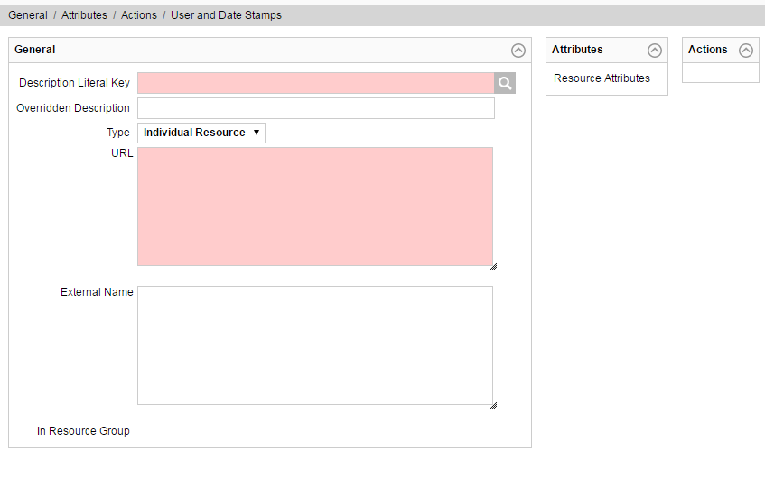

Figure 2 - Creating a new Resource

1. Enter a Resource Name using the naming convention above. Resource name must match the view name. See View Naming Convention.
2. Select a Description Literal Key. Literals are pre-defined user friendly labels, titles, etc. E.g. – item\_master\_load.
3. Overridden Description (Optional) is used to override the literal key description that is displayed for the resource.
4. Type should be set to “Individual Resource”.
5. URL should be as follows:

{meta.engine\_url}?resourceName=<resourcename>& {%trail%}

Where <resourcename> is the value entered for the resource that is being created.

Values delimited by curly braces {} are macros. The value within the braces may consist of any system environment variable. Some common url system variables are listed below:

|  |  |
| --- | --- |
| URL Macro | Description |
| {general.base\_url} | Will be replaced internally with the base URL for all Web application resources. |
| {portal.home\_url} | Will be replaced internally with the base URL for the application portal. A good example of where this can be used is when defining resource synonyms. |
| {meta.engine\_url} | Will be replaced internally with the base URL for the metadata engine servlet. |
| {meta.base\_url} | Will be replaced internally with the base URL for the metadata engine. |
| {resource.base\_url} | Will be replaced internally with the base URL for all Web application resources. |

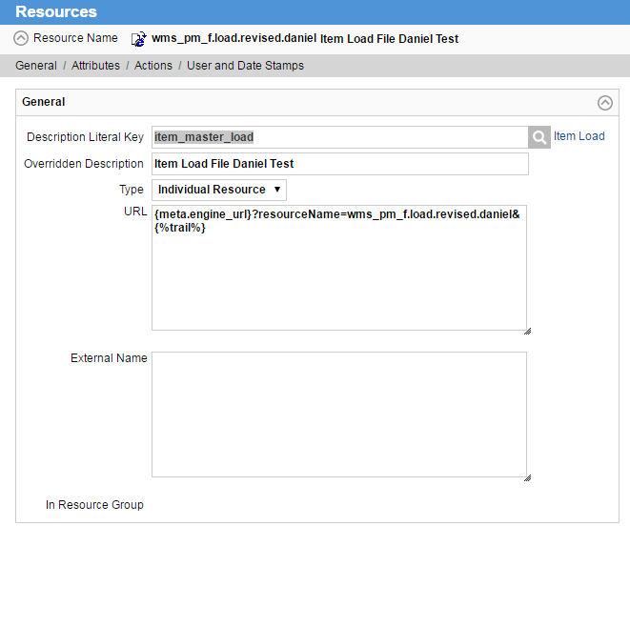

Figure 3 - Completed Resource Example

1. Click Submit.
2. Edit the newly created resource.
3. Click “Add Permissions”

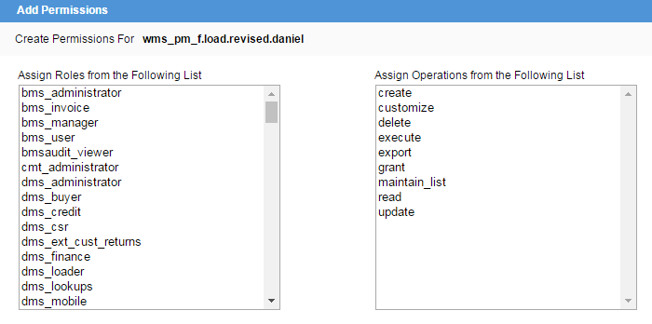

Figure 4 - Add Permissions for Resource

* 1. Select the roles that should have access to the resource. E.g. wms\_administrator
  2. Select the operations that users of the role should be able to perform
  3. Click Submit

1. Click Submit

## Creating View

1. Enter View Name using the naming convention below:

View Naming Convention:

* Database logical name + “\_” + table name (e.g. wms\_pm\_f)
* For a specialized view created from an existing view, the view name should be as above followed by a “.” + usage (wms\_pm\_f.load)

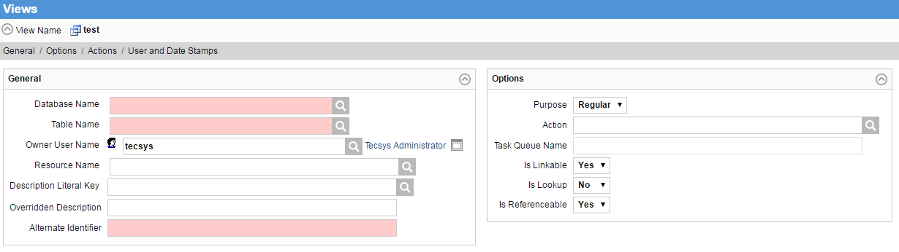

Figure 5 - Creating a new view

1. Database Name – Enter the database the view will be based on. E.g. wms
2. Table Name – Enter the name of the table to base the view on. E.g. pm\_f
3. Owner User Name – The name of the user that will be the owner of the view. E.g. system
4. Resource Name – The name of the resource the view is based on. It should be the same as the view name. E.g. wms\_pm\_f.load
5. Description Literal Key – Optional. Literals are pre-defined user friendly labels, titles, etc. E.g. – item\_master\_load.
6. Overridden Description – Optional. If provided will override the Description Literal Key value.
7. Alternate Identifier – An alternate to the domain value name. Must be unique. It is used in the java backend.
8. Purpose – Select Regular. Regular indicates that the view is not associated with an action. Task indicates that the view is associated with an action.
9. Action – Leave blank for Regular. Required for Task purpose.
10. Task Queue Name – Leave blank for regular. Only applicable to Task purpose. The name of the queue to which the task is posted.
11. Is Linkable – Select No. Indicates whether or not the view is available for linking.
12. Is Lookup – Select No. Indicates whether or not the view is used as a Lookup View.
13. Is Referenceable – Select No. If set to yes, it will show a list of views that the information relates to instead of the detail when a record from this view is selected.
14. Click Submit.

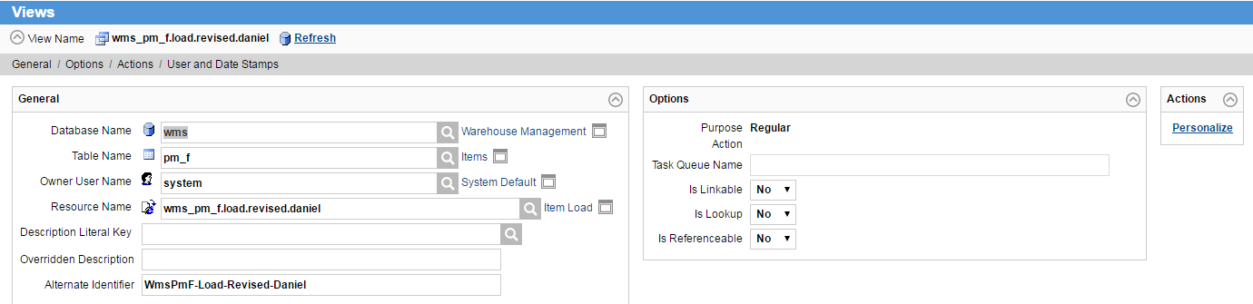

Figure 6 - Completed View

1. Edit the view that was just created.
2. Under Actions, click on Personalize.
3. View Personalize Search Criteria
   1. Select the fields from the left (Hold CTRL while clicking to select more than one) that should appear in the search screen for this view. Once all the fields are selected (this can be done one at a time too), click Add to add them to the right hand list pane. The fields listed on the right will be available to the user to search from. Similarly, to remove a field, select it and click Remove. The order can be changed by selecting an item then clicking Move Up or Move Down on the right.

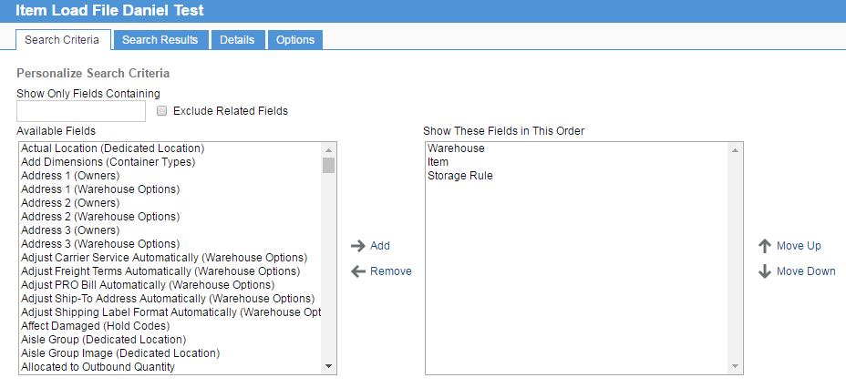

Figure 7 - View Personalization Search Criteria

1. View Personalize Search Results
   1. Select the columns that will be displayed in the results grid once a user executes a search. Note that the section “Result Details” must be at the top.
   2. The search results can also contain additional information such as Totals, Subtotals, and Grand Totals by selecting the appropriate option in “Display Search Results With” dropdown.

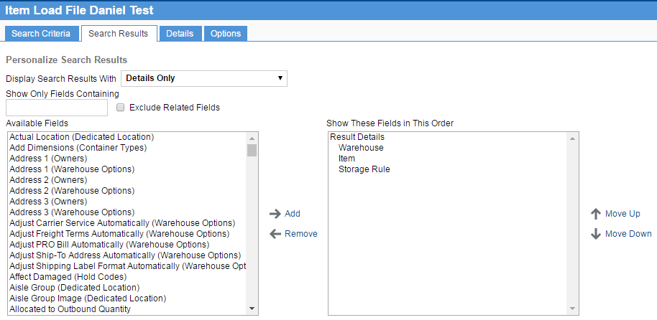

Figure 8 - View Personalization Search Results

1. View Personalize Details - The values listed here (all fields selected for each category will be the total details displayed / available to load) will determine which fields may be loaded during a data load and/or which fields will be displayed when a user selects details for a row in the Search Results.
   1. At the top of the form is a dropdown list with the following values: Key, Main Context, and Main. There may be additional values (e.g. Item Extended Descriptions) depending on the source table definition. Default will state “Main”. The list of available fields may be different for each category.
   2. In order to add fields to the right hand side list, they must be headed by a Detail Section Description. To add a section, enter a value in the “Detail Section Description” textbox, and then click “Add Section Title”. In the right hand list box, move the section above the values to be included in the section.
   3. For the “Key” fields, select the values from the left hand side which, when queried, return a unique record. E.g. – Warehouse and Item

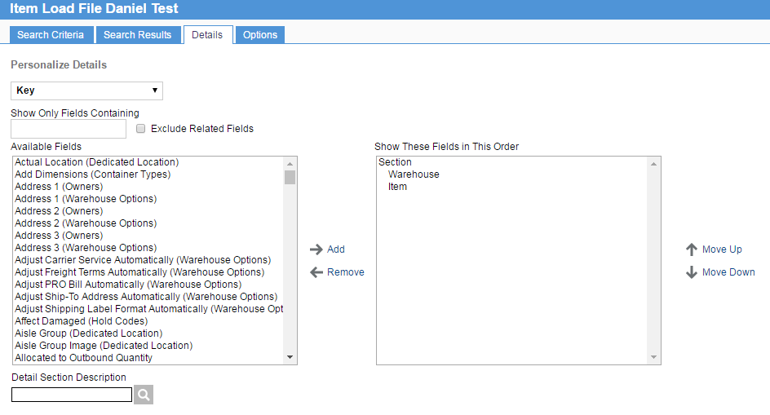

Figure 9 - View Personalization Details: Key

* 1. For the “Main Context” fields, select the “Key” fields that should be displayed. “Key” fields cannot be listed in both “Main” and “Key”.

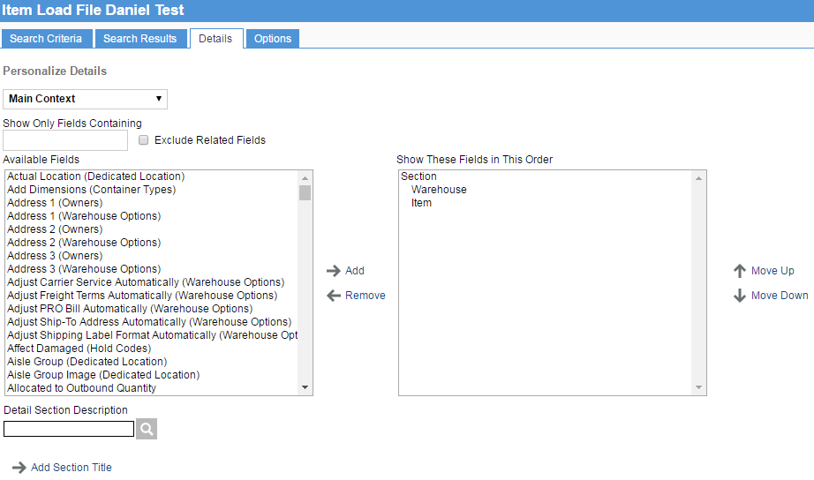

Figure 10 - View Personalization Details: Main Context

* 1. For the “Main” or additional category (e.g. – Item Extended Descriptions) fields, select the fields that should be displayed. Note that fields selected cannot exist in both “Key” and “Main”.

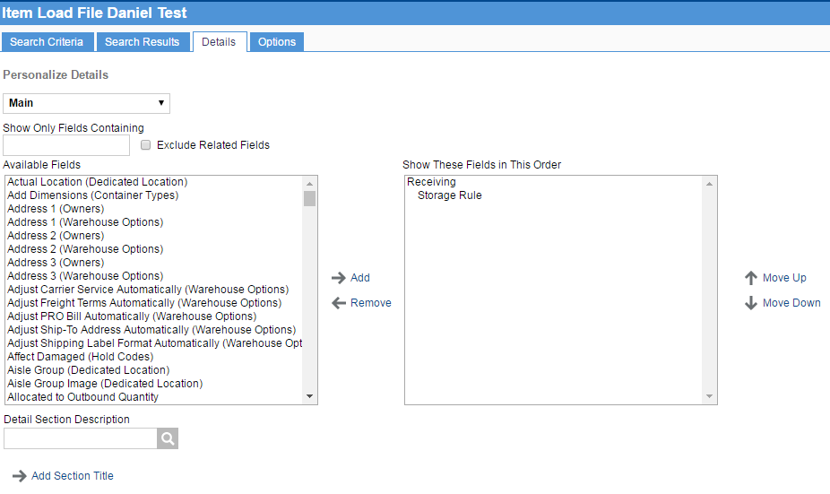

Figure 11 - View Personalization Details: Main

1. View Personalize Options – This is used to determine the behavior of the view
   1. Number of Rows per Page – This setting will determine how many search results are displayed in the grid per page. User Default will use the value set for the user performing the search. Default is 10.
   2. Maximum Number of Rows to Retrieve – This setting will determine the maximum number of rows to display in the search results when the user clicks on “Show All”. Defaults to 400.
   3. Related Resource Group – The resources assigned to the resource group are displayed in the related resource bar in the details page.
   4. Automatically Perform a Search When the Number of Rows is Less Than – When the total records in the view is less than this number, they will be displayed in the Search Results grid automatically. Default is 10.
   5. Automatically Perform a Search When You Enter Criteria – Set to Yes to trigger the search automatically as soon as the user tabs out of a criteria field. Default is No. This should not be changed.
   6. When a Search Finds a Single Row – When a search would return only a single record, the application can either display the single result in a grid, or can go directly to the record details.
   7. Record Creation – Alters behavior around record creation, allowing for record creation to be done in a single step, or two steps.
      * Enter Key and Go to Main Details, where the record is created in two steps;
      * Enter Key and Save, where the record is created in a single step;
      * Enter Key, Save and Go to Main Details, where the record is created in a single step and remains in modification mode;

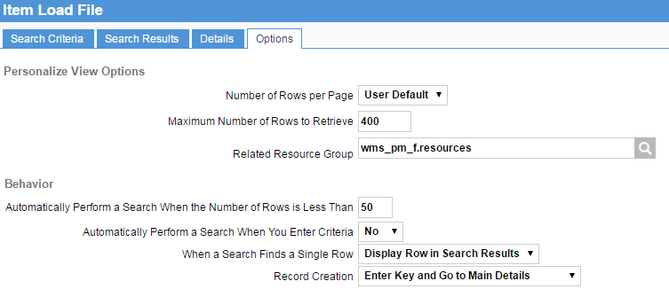

Figure 12 - View Personalization Options

# KDC Sections

Sections define how WMS outbound process is governed. Sections and warehouse search paths are closely related. A *Section* defines a series of locations that, for outbound order planning and replenishment purposes, are considered “equally good to pick from”. The search path identifies the system path to find product for pick and replenishment.

As suggested by Tecsys the standard types of sections should cover most typical warehouses scenarios below as applied to LDB business.

* PCD, Potential Cross-dock
* Pick
* Fast Moving Pallet
* Long Term Storage
* High Volume Replenishment (from)
* Customer Specific Product

Section Naming Convention

* S + grouping of location

Sections defined for the warehouse have the objective to breakdown the warehouse in logical sections such as:

* Bottle Pick
* NSWP
* Promo
* Partials
* No Pick, etc

Sections:

|  |  |  |
| --- | --- | --- |
| Section | Explanation | Scenario |
| S-CASEP | Identifies all pick locations in warehouse for case pick, with the exception of pick locations defined separately such as bottle pick, e.g. NSWP and PROMO | Pick |
| S-CASER | Identifies all reserve location in warehouse | Pick |
| S-DOCK | Identifies all location by the warehouse docks (shipping/receiving lanes) | Shipping/Receiving |
| S-INVM | Identifies all high value cage pick locations | Pick |
| S-NPCK | Identifies locations that are not used for picking such as Recoup, Delist, etc. | No pick, specialized locations |
| S-OVER | Identifies locations for overshipped products | Shipping/Receiving |
| S-SVXDOCK | Identifies SV Vancouver storage area | Consolidation |

## 

## Warehouse Search

Warehouse Searches define the system order to locate a product in the warehouse for pick or replenishment. The system will stop when first viable product is located. The configuration concentrates on combination of two aspects:

* Order that sections should be searched in
  + i.e.: case reserve -> case pick -> dock storage
* And what should be searched in the section
  + I.e: pallet pick (full load, clean partial), case (full case, forward pick)
* There are several search path created
  + WSP1
    - Main warehouse search that searches all regular pickable location
  + WSINVM
    - Searches Inventory section for product to pick
  + WSP1INVM
    - Searches main warehouse and inventory for product to pick
  + WSOVER
    - Search S-OVER section for over shipped product
* There are also replenishment search paths, these cover cases as these are the only items being replenished
  + FPSP-CS
    - Searches all reserves for available cases for replenishments

Sample searches set up are below.

|  |  |  |
| --- | --- | --- |
| Search | Explanation | Logic |
| WSP1 | Main warehouse search path 1 | Pick |

All warehouse searches search for the product in the following priority (similar to VDC):

* Full pallet
* Partial Pallet
* Full Case

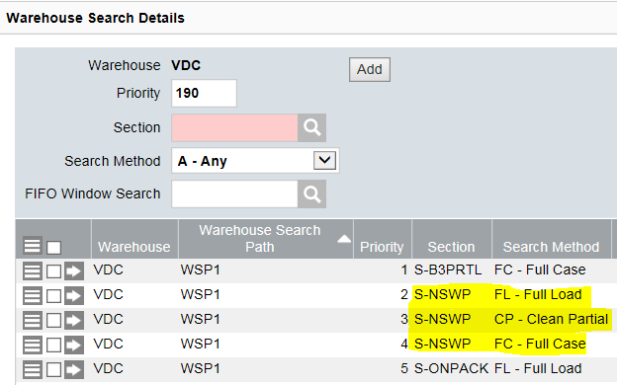

# Hold Codes TBD

Hold codes are used for putting product and/or locations on hold. Affected damaged drives functionality in WMS about what can be done with the product. Hold codes have a maximum length of four characters.

* Damage “Yes” means that product are truly damaged and cannot be considered stock
* Damage “No” means that product are on hold but not damaged

# Reasons TBD

INV.ADJ.BR02.FR01

Below changes highlighted in colours to be confirmed with Raul. Adjustment Type columns to be filled by Raul as well.

DUPLICATES

NEWLY ADDED

TO BE REMOVED FORM THE DOCUMENT

|  |  |  |  |  |  |  |  |
| --- | --- | --- | --- | --- | --- | --- | --- |
| **WMS** | | **Adjustment Type** | | | | | |
| **Reason** | **Description** | **Claimable Breakage** | **Shrink** | **Non Claimable Breakage** | **Write off** | **RMA** | **Bordeaux** |
| 01\_INVENTORY\_ADJUST | Inventory Adjustment |  | **X** |  |  |  |  |
| 04\_LDB\_DMG\_NC | Warehouse Damage |  |  | **X** |  |  |  |
| 07\_SUPPLIER\_DMG\_C | Supplier Damage | **X** |  |  |  |  |  |
| 10\_RESOLVED | Resolved |  |  |  |  |  |  |
| 13\_DEFECTIVE\_PACKAGING\_C | Defective Packaging | **X** |  |  |  |  |  |
| 14\_RTV\_OVERSHIP\_WMS\_ONLY | RETURN TO VENDOR FOR OVERSHIP (WMS ONLY) |  |  |  |  |  |  |
| 16\_HIDDEN\_DMG\_C | Hidden Damage | **X** |  |  |  |  |  |
| 19\_RECEIPT\_DMG\_C | Receipt Damage | **X** |  |  |  |  |  |
| 22\_AGENT\_RTV\_C | Agent Request | **X** |  |  |  |  |  |
| 25\_LDB\_RTV\_C | LDB Request | **X** |  |  |  |  |  |
| 28\_AGENT\_EXPIRED\_C | Defective Product | **X** |  |  |  |  |  |
| 28\_LDB\_EXPIRED\_NC | Defective Product |  |  |  | **X** |  |  |
| 29\_PENDING\_RESOLUTION | PENDING RESOLUTION |  |  |  |  |  |  |
| 30\_DATA\_ENTRY\_ERROR | DATA ENTRY ERROR |  |  |  |  |  |  |
| 31\_PRODUCT\_RECALL\_C | Recall | **X** |  |  |  |  |  |
| 34\_AGENT\_DMG | Agent Damage | **X** |  |  |  |  |  |
| 43\_GLS\_GENERAL\_RTN | GLS General Return |  |  |  |  | **X** |  |
| 46\_GLS\_IMPORT\_BEER\_RTN | GLS Import Beer Return |  |  |  |  | **X** |  |
| 49\_WCC\_GENERAL\_RTN | WCC General Return |  |  |  |  | **X** |  |
| 52\_WCC\_IMPORT\_BEER\_RTN | WCC Import Beer Return |  |  |  |  | **X** |  |
| 55\_WCC\_DUTY\_FREE\_RTN | WCC Duty Free Return |  |  |  |  | **X** |  |
| 58\_CARRIER\_DMG\_C | Carrier Damage | **X** |  |  |  |  |  |
| 58\_LDB\_CARRIER\_DMG\_NC | Carrier Damage |  |  | **X** |  |  |  |
| 60\_RECEIPT\_DATE\_CHANGE | RECEIPT DATE CHANGE |  |  |  |  |  |  |
| 61\_BORD\_CHILD\_TO\_MUM | Bordeaux |  |  |  |  |  | **X** |
| 64\_BORD\_INCREASE\_MUM\_SKU | Bordeaux |  |  |  |  |  | **X** |
| CCYC | Cycle Count |  |  |  |  |  |  |
| 70\_WAREHOUSE\_TRANSFER | DC2DC DDC RECEIVING |  |  |  |  |  |  |
| 71\_VDC\_DDC\_TRANSFER VDC TO | VDC TO DDC OR DDC TO VDC TRANSFER |  |  |  |  |  |  |
| 80\_DRY\_GOODS\_RECEIVING DRY | DRY GOODS RECEIVING |  |  |  |  |  |  |

# Container Types TBD

Configure the container types available to the system for tasks. This is a mix of LDB created and Tecsys supplied containers.

The LDB custom containers defined are:

* RPAL – Retail Pallet
  + Container is set to fill to 75% to account for chimney build and mix of box sizes in an order pick
  + There will be one pallet type set up in system, as per business, that represents several variations of the retail pallet
    - This is due to the large amount of variation between the boards
    - Average weight to be used for all boards provided by business
* WPAL – Wholesale Pallet
  + Container is set to fill to 75% to account for chimney build and mix of box sizes in an order pick
  + There will be one pallet type set up in system, as per business, that represents several variations of the retail pallet
    - This is due to the large amount of variation between the boards
    - Average weight to be used for all boards provided by business
* FULL – Full Pallet Load
  + This is a copy of the default LOAD pallet, used by the system for full pallet pick

## Container Selection Codes TBD

Configured to relate a container to a process (area), it lists the order and container types the system should use to select a container for the area. There are 4 scenarios created to attach to different areas:

* BTLL – Bottle Pick Large Box (AB3L)
* BTLR – Bottle Pick Regular Box (AB1R, AB2R, AB3P)
* BTLT – Bottle Pick Tall Box (AB3L)
* PAL – Pallet Logic

Details are listed below.

|  |  |  |
| --- | --- | --- |
| Container Selection Code | Explanation | Logic |
| BTLR | Container selection logic for bottle pick level 1 and 2 |  |
| BTLL | Container selection logic for bottle pick level 3 irregular and slow bottles |  |
| BTLT | Container selection logic for bottle pick level 3 tall bottles |  |
| PAL | Container selection logic for pallet pick |  |
| CAGE | Uses the same containers as PAL but have to be set up as different container selection code to separate CAGE picks into an individual container |  |
| FULL | Default code for full pallet picks |  |

# Zones

Zones are used for put away and store tasks in Tecsys. They have been configured to reflect a naming convention proposed by Tecsys and accepted by the business.

Naming Convention:

* Naming
  + Standard zone
    - ZaaS - where;
      * Z 🡺 Prefix
      * aa 🡺 Aisle ID
      * S 🡺 Suffix from grid (below)
  + Special Zones
    - Delisted products
      * DLST is the zone name
    - Supervisor Issues
      * SUPR is the zone name
    - No location can be found
      * NOLC is the zone name
    - New Product (NEWACT)
      * NACT is the zone name
    - Recoup
      * RECP is the zone name
    - Ship and Receive Dock
      * DOCK is the zone name
    - SV / Customer Cross docking from DDC
      * SVXD is the zone name
* Some conventions established
  + Main warehouse
    - A zone will be only cover one aisle in most cases
    - For the pallet racking reserve levels 1 & 2 will be assigned to the same zone (ex. Zxx**G**), Reserve Levels 3 will be assigned to its own zone (ex. Zxx**N**)
* Zone Suffix Grid
  + The zone suffix grid is a pattern to establish a zone boundary represented by a combination of height and placement within a rack/aisle combination that are part of a group that can be used equally to store product
    - 9 zones per regular aisle
      * Naming schema below, initiate with assigned letter
      * 3 horizontal breaks : pick level, 2 above, top 1
      * 3 vertical breaks down per aisle

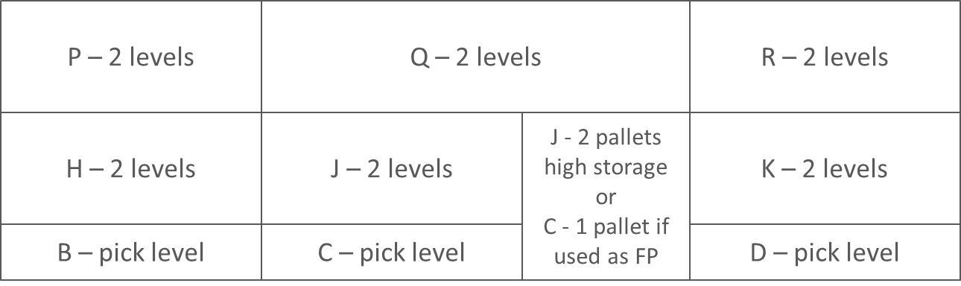

* + - Back wall
      * Naming schema below, initiate with assigned letter
      * 3 horizontal breaks : pick level, 2 above, top 1
      * 4 vertical breaks down along back wall
        + This may lead to different aisles having different zones depending of which aisles the locations belong to.

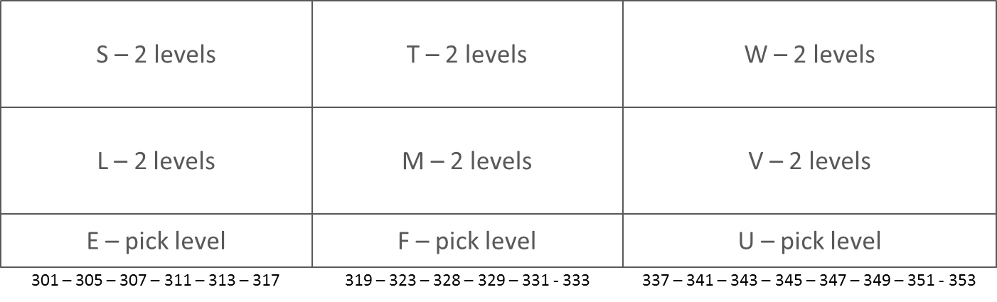

* + This Zone Suffix Grid offers provisions for future expansion. The letters in yellow of suffixes are reserved for the future expansion for location naming.

|  |  |  |  |  |  |  |  |
| --- | --- | --- | --- | --- | --- | --- | --- |
| N | P | Q | R | S | T | W | Z |
| G | H | J | K | L | M | V | Y |
| A | B | C | D | E | F | U | X |

Dock ………….Back ……………………….Back Wall

* + The agreed upon convention represents:
    - Letter A represent the single deep rack ground locations in SV Broadway
    - Letter G (above A) represent groups of reserve level 1 & 2 locations in SV Broadway
    - Letter N (above G) represent groups of reserve level 3 locations in main SV Broadway
    - Letter B (front) represent group of ground locations before the tunnel in main aisles
    - Letter H (front) represent groups of reserve level 1 & 2 locations before the runnel in main aisles
    - Letter P (front) represent groups of reserve level 3 locations before the tunnel in main aisles
    - Letter C (middle) represent group of ground locations before/after/includes tunnel in main aisles
    - Letter J (middle) represent group of reserve level 1,2 locations before/after/includes tunnel in main aisles
    - Letter P (middle) represent groups of reserve level 3 locations before/after/includes tunnel in main aisles
    - Letter D (back) represent groups of ground locations after the tunnel in main aisles
    - Letter K (back) represent groups of reserve level 1 & 2 locations after the tunnel in main aisles
    - Letter R (back) represent groups of reserve level 3 locations after tunnel in main aisles
    - Letter E (backwall) represent groups of ground locations in lower bay# narrow aisle
    - Letter L (backwall) represent groups of reserve level 1 & 2 locations in lower bay# narrow aisle
    - Letter S (backwall) represent groups of reserve level 3 locations in lower bay# narrow aisle
    - Letter F (backwall) represent groups of ground locations in center of narrow aisle
    - Letter M (backwall) represent groups of reserve level 1 & 2 locations in center of narrow aisle
    - Letter T (backwall) represent groups of reserve level 3 locations in center of narrow aisle
    - Letter U (backwall) represent groups of ground locations in high bay# of narrow aisle
    - Letter V (backwall) represent groups of reserve level 1 & 2 locations in high bay# of narrow aisle
    - Letter W (backwall) represent groups of reserve level 3 locations in high bay# of narrow aisle
  + Bulk zones are slights different in that they only have bottom level
    - Letters X represent groups of reserve level locations that will NOT have a storage rule currently bulk storage on aisle 25 and on the dock

# Storage Rules

These rules guide the system logic on how to store a particular product. They are assigned to an item.

The rules were written by the SAs to support storage sequence by aisle so items aren’t stored too far from their assigned forward pick.

Search

* All rules will search though the full warehouse
* ½ pallets must be stored on top of single rack aisle first, only when these locations are full can they be stored in a full pallet location. Independent of FP location in warehouse.

Product breakdown in general terms for Forward pick (for aiales)

* SV Broadway - Aisle 40 (no FP)
* Aluminum – aisle 10-15
* Wine & Spirits – aisle 16 - 21
* Promo – Aisle 26
* Inventory – Right side of building in open area by aisle 25

Aisle with Special Use

* Aisle 40 is all storage with no forward pick
* Tunnel location may be used as reserve, FP or as tunnel
* “Extra” floor reserve locations in aisles will be used as reserve mostly and will be part of the aisle zones, except for tunnel location that have been previously racked those will be set-up as forward pick
* “Extra”” floor reserve location on dock will be used as reserve, these location are not in any storage rule, the expectation is that a supervisor will direct product for storage in locations

Hold Codes

* Storage rules for product on hold; all hold codes to be reviewed with business to see if applicable for storage rule addition
  + DAMG (damaged) – TBD
  + EXP (expired) – TBD
  + PKSZ (pack size) – TBD
  + QC (quality control) – TBD
  + RCPH (recoup hold) – TBD
  + RTV (return to vendor) – TBD
  + SE (special events) – TBD
  + STDT (stale date) -- TBD

FIFO Pick Locations

* No storage rule for FIFO pick products
* Expectation is that all products will have a forward pick
* Products with no Forward Pick can use SRSUPR and be moved manually to a FIFO pick location

NSWP

* Storage Rule automatically assigned when new items is created in WMS, will default to SRNSWP
* Storage rule is minimal at KDC just sending to supervisor as there is no expectation that NSWP products will be received by the warehouse

User Directed Putaway

* Business has requested that in several situations put away be driven by users
* All products must have a storage rule associated, it is a mandatory field
* If there are products that should NOT have a storage rule, the rule SRSUPR should be used
  + Storage rule will lead the product to the Supervisor issue location for manual putaway

List of Special Storage Rules

* SROPEN
  + Default storage rule to be assigned to item “Open” to reserve locations as FP until a real item is assign to the location
* SRNEWACT
  + Storage rule for re-activated items
* SRNSWP
  + Automatically assigned when a new item is created if it is NSWP
  + Directs to NSWP pick locations by office
* SRSUPR
  + Product has an issue that requires supervisor attention before storage or to define storage
  + User directed putaway
  + Directs to Supervisor location by office
* SRLISTCHG
  + List change NSWP to Stock in CPD updates product storage rule in WMS
  + Directs to Supervisor location by office
* SRDELIST
  + Storage rule for delisted items coming from ebiz
* SROVER
  + Product that is in warehouse but was over shipped so no PO exists for the product
  + This is a generic product at the warehouse that does not interface to eBiz
  + Directs to special location in INVM
* SRRETURN
  + Product to be returned to vendor
  + This is a generic product at the warehouse that does not interface to ebiz
  + Directs to special location in INVM

Naming Convention for storage rules with the exception of the special ones listed above:

* SR10G = SR + AISLE + ZONE
  + SR = Storage Rule identifier
  + 10 = Aisle
  + G = Zone

Within each rule there are a series of consolidation, zones and search rules the system will follow when putting away the item.

|  |  |  |
| --- | --- | --- |
| Sample Type | Explanation | System Sample |
| SR10B | Aisle 10  Zone B | TBD |
| SR14C | Aisle 14  Zone C | TBD |
| End part of Storage Rules  TBD | All SR | This end of all rules is the same, if a location cannot be found within the logic the pallet is sent to the NOLC (No location zone) for the supervisor to analyze why and make decisions about where to store the item. |

The detail storage rule planning approved for the KDC warehouse can be found in the [appendix](#_Appendix_1_–) for this document.

The detail storage rule planning approved for the Kamloops warehouse can be found in Sharepoint at:

TBD.

Upload Storage Rules

* Use upload with Excel, load file has issue and is not working in Tecsys
* Select one storage rule, and edit with excel
* Add to the excel the details for ALL the storage rules you want to update
* You do not have to update one storage rule at a time

# Areas

Areas define how people work in the warehouse. This includes:

* Where documents and labels print
* What confirmation are valid for tasks in the area
* Container selection code
  + What containers are valid for picks in area
* Equipment valid for pick – i.e “RF, labels”
* Type of pick
* Specification for main tasks completed in area such as
  + Label requirements
  + Equipment used in area for tasks
  + How long a task can age before it triggers a notification
  + Cycle count setting for locations in area

The configuration has split the warehouse in large areas mainly by picking logic:

* Case pick area
* Specialty pick :
  + Inventory Control
  + Reserve
  + Dock and Aisle 26 Bulk Storage Locations
* Non picking area
  + Dock
  + SV Broadway

Below are the areas where print pick labels would print:

* Inventory Control CPREs would print in TBD station printer
* Full pallet picks would print in TBD station printer
* All other CPREs for case pick would print in base station printer (main office)

Areas

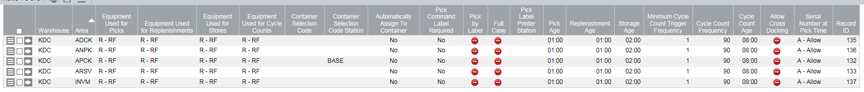

TBD: Decide on cycle count approval item below as DDC has applied this setting to APCK, and current setting are a copy of DDC

The following Areas will be configured to not require approval for cycle counts (to prevent locking of bins. All other areas will require approval for exceptions.

* APCK

## Confirmations for Tasks

For each area the system requires settings for what type and how many confirmations are required.

KDC and DDC will have the same area task confirmation settings, unless KDC has specific requirements.

Sample below:

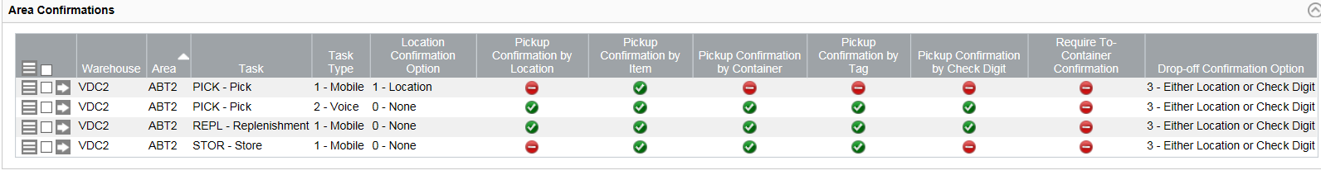

# Location Planning

Location planning was a collaboration between LDB Business, LDB SA, and Tecsys.

## Bay Numbering

Warehouse divided logically for bay numbering

* 100 – aisles, above forklift highway
* 200 – aisles, below forklift highway, inventory and tunnel
* 300 – back wall and to the back right
* 400 – dock storage

## 

## Aisle

Travel direction for aisles in the system.

* Even aisle
  + Direction: dock to back of building (down)
* Odd aisle
  + Direction: back of building to dock (up)
* Aisle ID start at 10 for numbering purpose (sequencing) from left to right
* Back wall
  + Back wall racks, actual bays are part of the even downward aisles.

To enforce aisle direction the command sequence numbers assigned to the locations defines the order that location tasks are created, such as pick.

Sample of bay numbering for odd and even aisle is below.

|  |  |  |  |  |  |  |  |  |  |  |  |  |  |  |
| --- | --- | --- | --- | --- | --- | --- | --- | --- | --- | --- | --- | --- | --- | --- |
| Even aisle physical sequence | | |  | Odd aisle physical sequence | | |  | Even aisle command sequence | | |  | Odd aisle command sequence | | |
| EVEN Rack |  | ODD Rack |  | ODD Rack |  | EVEN Rack |  | EVEN Rack |  | ODD Rack |  | ODD Rack |  | EVEN Rack |
| Physical Sequence Bin | Position | Physical Sequence Bin |  | Physical Sequence Bin | Position | Physical Sequence Bin |  | Command Sequence Bin | Position | Command Sequence Bin |  | Command Sequence Bin | Position | Command Sequence Bin |
| 100 | 1  5 9 | 101 | 1 | 118 | 9  5 1 | 119 |  | 100 | 1  5 9 | 101 | 1 | 216 | 9  5 1 | 217 |
| 104 | 1  5 9 | 103 | 2 | 116 | 9  5 1 | 115 |  | 104 | 1  5 9 | 103 | 2 | 214 | 9  5 1 | 213 |
| 106 | 1  5 9 | 107 | 3 | 112 | 9  5 1 | 113 |  | 106 | 1  5 9 | 107 | 3 | 210 | 9  5 1 | 211 |
| 110 | 1  5 9 | 109 | 4 | 110 | 9  5 1 | 109 |  | 110 | 1  5 9 | 109 | 4 | 208 | 9  5 1 | 207 |
| 112 | 1  5 9 | 113 | 5 | 106 | 9  5 1 | 107 |  | 112 | 1  5 9 | 113 | 5 | 204 | 9  5 1 | 205 |
| 116 | 1  5 9 | 115 | 6 | 104 | 9  5 1 | 103 |  | 114 | 1  5 9 | 115 | 6 | 202 | 9  5 1 | 201 |
| 118 | 1 5 9 | 119 | 7 | 100 | 9 5 1 | 101 |  | 118 | 1 5 9 | 119 | 7 | 118 | 9 5 1 | 119 |
| 202 | 1  5 9 | 201 | 8 | 216 | 9  5 1 | 215 |  | 202 | 1  5 9 | 201 | 8 | 114 | 9  5 1 | 115 |
| 204 | 1  5 9 | 205 | 9 | 212 | 9  5 1 | 213 |  | 204 | 1  5 9 | 205 | 9 | 112 | 9  5 1 | 113 |
| 208 | 1  5 9 | 207 | 10 | 210 | 9  5 1 | 209 |  | 208 | 1  5 9 | 207 | 10 | 110 | 9  5 1 | 109 |
| 210 | 1  5 9 | 211 | 11 | 206 | 9  5 1 | 207 |  | 210 | 1  5 9 | 211 | 11 | 106 | 9  5 1 | 107 |
| 214 | 1  5  9 | 213 | 12 | 204 | 9  5  1 | 203 |  | 214 | 9  5  1 | 213 | 12 | 104 | 9  5  1 | 103 |
| 216 | 1  5 9 | 217 | 13 | 200 | 9  5 1 | 201 |  | 216 | 1  5 9 | 217 | 13 | 100 | 9  5 1 | 101 |

|  |  |  |  |  |  |  |  |  |  |  |  |  |  |  |  |  |  |  |  |
| --- | --- | --- | --- | --- | --- | --- | --- | --- | --- | --- | --- | --- | --- | --- | --- | --- | --- | --- | --- |
| 353 | 351 | 349 | 347 | 345 | 343 | 341 | 337 | 333 | 331 | 329 | 328 | 323 | 319 | 317 | 313 | 311 | 307 | 305 | 301 |

Some notes regarding KDC aisles:

* Aisle 10 is different as it has less bays. Bays removed
* Aisle 40 has only 6 bays – even side
* Pallet Stacker Aisles
  + All stacker “rack locations” have been removed from system location file as these do not exist
    - Removed - On ODD side at top of aisles 13, 14, 17, 18, 21 and 22
      * Aisle 13 – bay 119
      * Aisle 14 – bay 101
      * Aisle 17 – bay 119
      * Aisle 18 – bay 101
      * Aisle 21 – bay 119
      * Aisle 22 – bay 101
* Tunnel Locations
  + All floor reserve location created and put on hold with status “Tunnel”
  + Identified level set to “A”
  + Some “tunnel” locations have been racked so the tunnel is only in sections in the warehouse it is not a continuous tunnel like in DDC
* Single aisle bay numbering
  + Will follow the same bay numbering schema as the double aisles in the same direction (just one side of the aisle is removed)
* Back Wall
  + Specific narrow aisle location classes to support separate equipment for all racks
* Aisle 40
  + Set all locations to FIFO as storage
  + Numbering for aisle is different with straight number increases based on odd/even (no skipped number logic)
  + Ground locations set to level A or A/B if two levels
    - Center aisle = A, one level at ground
    - Surround = A/B, two levels at ground as per KDC information
  + All locations for aisle 40 put on hold with code “SV”
* Wrapper
  + Physically located on the dock, no impact in racking locations
  + Uses two storage in physical aisles as wrapper staging

## Pick Path

Configuration reflects large zig-zag pattern Pick Path

* Requires number skips to work when numbering bays in a 2 alternating pattern
  + Because each bay in KDC is 3 locations, the pick path was based on 2 bays increments
* For aisle where pick only occurs on one side, the path is a straight line
* For aisle with double side pick path
  + Starting from top of building down, will be in reverse order when going up
  + See below for sample, where a picker has a pick at every location the path he would take

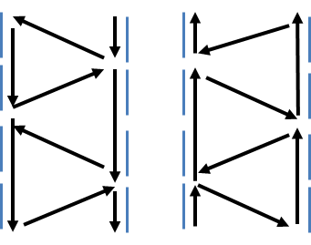

Logic for placement of items by velocity in pick path

* Place high velocity items in middle of the long stretch with 2 faces in pick path
* Place lower velocity item in positions where path shifts direction

## Aisle Group

Aisle group identifies to which aisle a location belongs.

* The naming convention being used is:

AG + AA

* + Where;
  + AG 🡺 Identifies the attribute as “Aisle Group”
  + AA 🡺 Aisle ID
    - Numeric, matching to the aisle ID

# Location Naming

A naming convention was developed for location. It varies slightly at certain specific areas but in general follows a set pattern. But as a rule no location name can be longer then 10 characters including dashes and spaces.

* Naming convention for product Location ID

AA-RRR-LP

* + Where;
  + AA 🡺 Aisle ID
    - Numeric, starting at 10
  + RRR 🡺 Rack/Bay ID
    - 100’s racks, for aisle before tunnel
    - 200’s racks, for aisle after tunnel and inventory area
    - 300’s racks, back wall of the warehouse and to right
    - 400’s for dock area storage
  + L 🡺 Level (Numeric for Pick Levels / Alpha for Reserve Levels)
    - Pick
      * 1 – Pick level 1, always floor (74 full pallet / 37 half pallet)
      * 2 – Half pallet elevated pick
    - Reserve
      * A – multiple uses but always indicates a floor reserve location
        + Floor Bulk and FIFO storage locations
        + Reserve floor location at Tunnel (3X2 capacity) (Height 139”)
        + Floor storage in SV Broadway racks
      * B – SV Broadway 2nd level rack reserve in ground level bay
      * T – First reserve level (65” full pallet / 32.5” half pallet)
      * U – Provision for splitting level into half pallet
      * V – Second reserve level
      * W - Provision for splitting level into half pallet
      * X – Provision for splitting top level into half pallet
      * Z – Reserve at top level

|  |
| --- |
| Insert pic |

* + P 🡺 Position on the level (“1” , “5”, “9” direction of Pick Path)
    - All bays have 1, 5 and 9
      * 1, 5 and 9 = used for normal slots
* Naming convention for special locations: staging aisles, shipping lanes, receiving lanes, recoup and doors locations

TTTT-ID

* + Where;
  + TTTT 🡺 Type of locations (up to 8 characters used)
    - Alpha
      * SHIP
      * RECV
      * DOOR
      * STG-ASL
      * RCP-TRAY
      * RCP-RECV
  + ID 🡺 Location identification
    - Numeric (between 2 to 5 digits available)
* Naming convention for special locations that represent issues and there is only one location in the warehouse for it

TTTTTTTTTT

* + Where;
  + TTTTTTTTTT 🡺 Type of location
    - Alpha, up to 10 characters
      * I.E:
        + DELIST
        + RECOUP
        + OVERSHIPMT
        + STORRETRN
        + LISTCHANGE
        + NEWACT
        + NOLOCATION
        + SUPERVISOR
        + QC
        + QA
        + EXIT
        + WRAPPER-1
        + WRAPPER-2



# Location Type

The LDB will be using the locations types below from Tecsys.

* Forward Pick
  + 100% of case pick locations in warehouse will be defined as forward pick
* FIFO
  + All reserve locations in racks will be defined as FIFO
  + Floor storage in aisle will be defined as FIFO
  + Special locations are mostly defined as FIFO
* BULK
  + Storage location in Dock
  + Storage locations in aisle 25
* DOOR
  + Doors 1 to 11
* RECV
  + Receiving Stage Locations 1 to 11 + letter for receiving lane identification in front of door
    - i.E.: RECV5A, RECV 5B, RECV 5C, RECV 5D
* SHIP
  + Shipping Stage Location on dock 1 to 11 + letter for shipping lane identification in front of door
    - i.E.: SHIP5A, SHIP5B, SHIP5C, SHIP5D
  + Stage in Aisle Location from 10 to 26 + B/F for staging identification in aisle (front or back)
    - i.E.: STG-ASL10B, STG-ASL10F
    - Some aisle are excluded as they are too narrow to stage or are used for wrapper staging
      * 11,17,22
* PACK
  + Wrappers 1 & 2

# Location Creation/ Upload

Location upload work off an excel table supplied by Tecsys. This excel table has multiple tabs to contribute towards the correct creation of the location load file.

Load files for locations configuration can be found at the following SharePoint locations:

* Locations only without Forward Pick Items slotting – follow this TBD
* Locations with Forward Pick Items slotting – follow this TBD

To upload finalized file please follow instructions in [Upload Configuration](#_Downloading_Configuration) section of this document.

Deleting location

* There must be no inventory or transactions to be able to delete a location
  + Due to audit trail functionality
* If there are transactions may need to delete from the backend
  + But may require delete to multiple tables, not easy
  + Not recommended

# Switch a FP to a Storage Location and Vice Versa

Location upload work off an excel table supplied by Tecsys. This excel table has multiple tabs to contribute towards the correct creation of the location load file.

# Warehouse Rack Plan

The warehouse has multiple types of racks. Rack type and dimensions feed into the system via the [location/equipment](#_Location_Class) class. Link to rack drawings folder is below.

* General warehouse racks

[Link](http://headoffice.bcldb.com/projects/LDBDC/DC-WMS/Project%20Documents/Forms/AllItems.aspx?RootFolder=%2Fprojects%2FLDBDC%2FDC%2DWMS%2FProject%20Documents%2F20%20%2D%20Analysis%20and%20Design%2FDesign%2FKLA%20Warehouse%20Design&FolderCTID=0x012000E1B295AC7647614EACAF6ADA026AED15&View=%7B6AED93DD%2D9495%2D4191%2DA93F%2D4A1E6710A39E%7D) TBD (Kal to either add rack drawing or link, ensure all racks are covered including SV Broadway (Ales has it))

# Mobile Equipment - TBD

Mobile equipment is configured for two purposes:

* Ensure tasks go to operators on correct equipment
  + E.g.: PFR (Pallet Mover, Fork Lift, Reach Truck, Narrow Reach Truck)

Each mobile equipment is configured to particular location classes which is what controls access to the locations.

The configuration is completed as follows:

|  |  |  |  |
| --- | --- | --- | --- |
| Warehouse | Mobile Equipment Type | Location Class | Capability |
| VDC | PFRH | D172 | B |
| VDC | PFRH | D187 | B |
| VDC | PFRH | HS25 | B |
| VDC | PFRH | HS38 | B |
| VDC | PFRH | P152 | B |
| VDC | PFRH | P187 | B |
| VDC | PFRH | P69 | B |
| VDC | PFRH | P76 | B |
| VDC | PFRH | T370 | B |
| VDC | PFRH | T81 | B |
| VDC | PFRH | T88 | B |
| VDC | PFRH | OTHR | B |
| VDC | PFRH | DOCK | B |
| VDC | PFRH | RECV | B |
| VDC | PFRH | SHIP | B |
| VDC | PFRH | RECP | B |
| VDC | PFRH | C187 | B |
| VDC | PFRH | C152 | B |
| VDC | PFRH | CS25 | B |
| VDC | PFRH | CS38 | B |

|  |  |  |  |
| --- | --- | --- | --- |
| Warehouse | Mobile Equipment Type | Location Class | Capability |
| VDC | PM | P187 | B |
| VDC | PM | D187 | B |
| VDC | PM | P69 | B |
| VDC | PM | P76 | B |
| VDC | PM | HS25 | B |
| VDC | PM | HS38 | B |
| VDC | PM | BL31 | B |
| VDC | PM | T370 | B |
| VDC | PM | OTHR | B |
| VDC | PM | DOCK | B |
| VDC | PM | RECV | B |
| VDC | PM | SHIP | B |
| VDC | PM | RECP | B |

|  |  |  |  |
| --- | --- | --- | --- |
| Warehouse | Mobile Equipment Type | Location Class | Capability |
| VDC | PFR | D172 | B |
| VDC | PFR | D187 | B |
| VDC | PFR | HS25 | B |
| VDC | PFR | HS38 | B |
| VDC | PFR | P152 | B |
| VDC | PFR | P187 | B |
| VDC | PFR | P69 | B |
| VDC | PFR | P76 | B |
| VDC | PFR | T370 | B |
| VDC | PFR | T81 | B |
| VDC | PFR | T88 | B |
| VDC | PFR | OTHR | B |
| VDC | PFR | DOCK | B |
| VDC | PFR | RECV | B |
| VDC | PFR | SHIP | B |
| VDC | PFR | RECP | B |
| VDC | PFR | BTPD | B |

# Location Class

There is no location class table in WMS. But location class/equipment class (same field) are used in locations and mobile equipment configuration and have to exist in a consistent manner for the system to validate between the two functionality groups.

Bellow is the table of all the location classes used in configuration and their sizing:

|  |  |  |  |  |  |
| --- | --- | --- | --- | --- | --- |
| Location Class | Height | Width | Depth | Weight | Aisle |
| P183 | 183 | 127 | 127 | 1700 | Bottom level of most rack aisles (72”) |
| P152 | 152 | 127 | 127 | 1700 | Reserve level of most rack aisles, except top level in single rack aisle (60’) |
| P96 | 96 | 127 | 127 | 850 | Top reserve for ½ pallet in single rack aisles (38’) |
| P368 | 368 | 127 | 127 | 10200 | Tunnel floor reserve (145’) |
| N183 | 183 | 127 | 127 | 1700 | Bottom level of back wall rack aisle (72’) |
| N152 | 152 | 127 | 127 | 1700 | Reserve level of back wall rack aisles (60’) |
| N1X3 | 456 | 127 | 127 | 5100 | Bulk Storage 1 pallet deep by 3 high in narrow aisle |
| B1X2 | 320 | 127 | 127 | 3400 | Bulk Storage 1 pallet deep by 2 high |
| B1X3 | 456 | 127 | 127 | 5100 | Bulk Storage 1 pallet deep by 3 high |
| B2X2 | 320 | 127 | 254 | 6800 | Bulk Storage 2 pallet deep by 2 high |
| B2X3 | 456 | 127 | 254 | 10200 | Bulk Storage 2 pallet deep by 3 high |
| B5X3 | 456 | 127 | 635 | 25500 | Bulk Storage 5 pallet deep by 3 high |
| B6X2 | 620 | 127 | 762 | 20400 | Bulk Storage 6 pallet deep by 2 high |
| F49 | 49 | 25 | 127 | 212 | Flow rack in SV - 25cm wide |
| F50 | 50 | 25 | 127 | 212 | Flow rack in SV - 25cm wide |
| P82 | 82 | 127 | 127 | 1700 | Floor reserves SV Broadway minus 5'pallet and 3' tech (32.5') |
| P107 | 107 | 127 | 127 | 1700 | Floor reserves SV Broadway minus 5'pallet and 3' tech (42.25') |
| DOCK | 200 | 200 | 2500 | 20000 | Locations for receiving, staging, doors, customer pick up |
| RECV | 200 | 200 | 2500 | 20000 | Receiving lanes |
| SHIP | 200 | 200 | 2500 | 20000 | Shipping lanes and consolidation area |
| RECP | 200 | 200 | 2500 | 20000 | Recoup location |
| OTHR | 200 | 200 | 2500 | 20000 | I.e: NOLOCATION, DELIST, LISTCHANGE, etc locations |

|  |  |  |
| --- | --- | --- |
| Rack Type | Loc Class | Explanation |
| A | P152, P183 | Single deep rack with 3 pallet reserve levels and 1 full pallet pick location |
| B | P96, P152, P183 | Single deep rack with 2 pallet reserve levels, 1 half pallet reserve level and 1 full pallet pick location |
| C | N152, N183 | Narrow aisle single deep rack with 3 pallet reserve levels and 1 full pallet pick loc |
| E | P152, B1X2 | Single deep tunnel rack with 2 reserve locations; 2 full pallet location |
| F | P152, P96, B1X2 | Single deep tunnel rack with 2 reserve locations; 1 ½ pallet and 1 full pallet loc. |
| G | P152, F49, P107 | Single deep rack with 5 reserve levels including: 1 ½ pallet, flow racks (either 7, 8), 3 level case reserve |
| H | P152, F50, P82 | Single deep rack with 5 reserve levels including: 1 ½ pallet, flow racks (either 10, 12), 3 level case reserve |

Naming convention for locations class

* Pallet Rack Locations
  + T + H
  + T – identifies the type of storage unit
    - Single Deep pallet rack 🡺 “P”
    - Single Deep pallet rack in narrow aisle 🡺 “N”
    - Flow case rack 🡺 “F”
  + H – Height of location
    - Height in the system is defined smaller than the physical height, minus clearance (3 inches) + pallet height (5 inches)
* Bulk Locations
  + T + H + “X” + S
  + T – identifies the type of storage unit
    - Bulk 🡺 “B”
  + H – Number of pallets stored horizontally
  + S – Number of pallets stacked
  + “X” – Separator between horizontal and vertical numbers
* Special locations
  + Alpha up to 4 digits

# Location Storage Sequence

Storage sequence is used to order put away tasks for an operator.

This uses the exact same order as the Command Sequence field. It is not very relevant for the implementation because all put always are usually one product at a time with no scheduled route stops so there is always only one task for the operator.

# Location Command Sequence

Command sequence is used to order pick tasks for an operator.

In even aisles it uses the location ID to create the path. In Odd Aisles the order in reversed so that the users have a seamless flow of going down and then up and aisle while picking.

# Check Digit

Random 3-digit number created on upload and assigned to a location. This is a valid task confirmation for a location in different tasks.

To confirm the tasks where check digit is a valid confirmation check settings for the relevant Area under [Area Confirmations](#_Confirmations_for_Tasks).

# Routing Logic

Certain activities will require a forced routing in the warehouse. A forced routing is a path that the tasks must follow to complete the activity, it may or not be completed by the same operator. Warehouse route points and routes have been created to support these processes.

## Route Points

Route points have been created for in the warehouse to represent a logical group of locations or a physical place in the warehouse that needs to be identified.

* A route point is different from a location as it has no size or attachment to section/zone/area.
* Every location has a route point identified that it belongs to.
* Route points:
  + RP-RES = Route Point Case Reserve
    - Attached to all locations that hold reserve stock
  + RP-PICK = Route Point Pick
    - Attached to all forward pick locations
  + RP-DOCK = Route Point Dock Doors
    - Attached to all dock doors
  + RP-QA = Route Point QA
    - Attached to QA location
  + RP-QC = Route Point QC
    - Attached to QC locations
  + RP-RECOUP = Route Point Recoup
    - Attached to all recoup locations
  + RP-SHIP = Route Point Shipping Dock
    - Attached to all shipping dock locations
  + RP-RECV = Route Point Receiving Dock
    - Attached to all receiving dock locations
  + RP-STGASLE = Route Point Staging Aisle
    - Attached to all staging aisle locations
  + RP-WRAPPER = Route Point Wrapper
    - Attached to all wrappers locations

## Routes TBD

The warehouse processes that have routes are: TBD

System sample of route:

* RP-PICK 🡺 DROP-BTL2 🡺PICK-BTL2 🡺RP-BTL2
* Pause field determines if there can be an operator change at the route point. If set to “Yes” it allow for a different operator to scan the tag and continue the task.

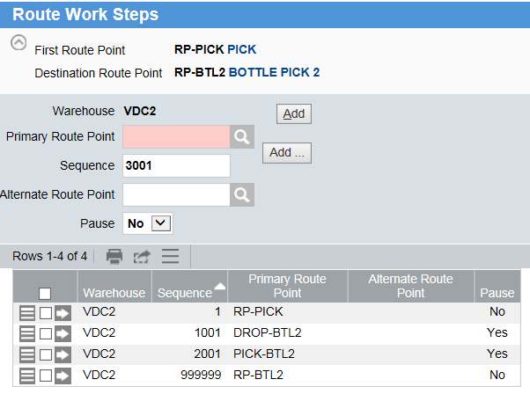

# Replenishment and Slotting TBD

Most products in the warehouse 95% will have one or more location assigned as a forward pick for the product. The type of location the product is assigned to is dependent on the product velocity.

Some important functionality that is defined at the forward pick configuration:

* When a product is assigned to a forward pick, the UOM trigger quantity field is what defines the PICK UOM at the location.
  + For bottle pick forward pick locations the UOM trigger must be set to “bottle”
  + For case pick forward pick locations the trigger UOM should be set to “case”

The replenishment and slotting rules for products will follow mostly the rack type it has been assigned to initially. Business users may customize specific items as required.

## A Racks

All A Racks will have initial replenishment rules set to 5 cases for all pick locations.

• Most high volume product is being placed in double deep and being replenished at full pallet load

Secondary rule – deferred

1 full layer replenishment

May apply to specific SKUs by velocity or specific aisles to be supplied by Business after go-live

## B Racks

Set replenishment level to 0 for all picks

* Because of the height an extra box cannot be added to the top in most cases
* Product is slow moving

# Item

## Definition

Please link to spreadsheet below with field based mapping definition for item data. Sample items have been set up in configuration system as samples.

[WMS Item Master and Item Alias](http://headoffice.bcldb.com/projects/LDBDC/DC-WMS/Project%20Documents/20%20-%20Analysis%20and%20Design/Development%20and%20Integration/Mappings/Item%20Master%20Interface/WMS%20Item%20Master%20and%20Item%20Alias.xlsx)

## Alias

This table will store all the SSC and UPC associated to a SKU, it will be loaded by the interface from host. Allows for the association between SSC and SKU and UPC and SKU without creating extra product lines.

## TI-High

2 custom numeric fields added to Item definition for Ti and High.

## Cage

1 custom alpha fields added to Item definition with Yes/No.

## "On pack" Promotional Product

On Packs at KDC will be treated as regular product, they will not be marked or handled separately.

TBD: Discuss with KDC impacts of using scales and having unmarked onpacks.

DDC process for onpacks \_\_\_\_\_\_

At receiving, if on-packs are detected the receiver will mark that instance of inventory as having on-packs via a custom field “On-packs” Yes/ No. The on-pack flag is associated to the instance of inventory for the SKU.

Below are the high level steps in creating an On Pack ware house section. This is all done on the **GOLD Environment**.

1. Update sections to On Pack
   1. Create the On-Pack section: S-ONPACK
   2. Update section on locations in the range of 40-2XX-XX and 41-2XX-XX using the excel file below (where XX is any symbol)
      1. [Location](http://headoffice.bcldb.com/projects/LDBDC/DC-WMS/Project%20Documents/Forms/AllItems.aspx?RootFolder=%2Fprojects%2FLDBDC%2FDC%2DWMS%2FProject%20Documents%2F30%20%2D%20Config%20and%20Dev%2FLDB%20SA%20Configuration%2FPackage%5FB%5FPicking&FolderCTID=0x012000E1B295AC7647614EACAF6ADA026AED15&View=%7B6AED93DD%2D9495%2D4191%2DA93F%2D4A1E6710A39E%7D) (link)
      2. File name: BC LS - WMS Location Master Andrei All Feb 2018
      3. Import the above file saved in the tab-delimited text format using the Tecsys view named wms\_lc\_f.load
2. [Remove storage rules](#_2._Remove_storage)
   1. Update excel files with storage rules (where XX is any symbol)
      1. [Location](http://headoffice.bcldb.com/projects/LDBDC/DC-WMS/Project%20Documents/Forms/AllItems.aspx?p%255FSortBehavior=0&p%255FFileLeafRef=wms%5Frl%5Ff%2Eload%20SR%20Details%20%2D%2D%20Aisle%2045%2Exlsx&RootFolder=%2Fprojects%2FLDBDC%2FDC%2DWMS%2FProject%20Documents%2F30%20%2D%20Config%20and%20Dev%2FLDB%20SA%20Configuration%2FConfiguration%20Documents%2FStorage%20Rules%20Files&PageFirstRow=1&View=%7B6AED93DD%2D9495%2D4191%2DA93F%2D4A1E6710A39E%7D) (Link)
      2. Name: wms\_rl\_f.load SR Details -- Aisle [XX]
   2. Update system
      1. Screen: Storage Rule Details (wms\_rl\_f)
      2. Delete storage rule details for storage rules that storing items in zones belong to 40-2XX-XX and 41-2XX-XX locations range
      3. Reload storage rule details from the section 2.a. spreadsheets using an update with excel function on wms\_rl\_f view
3. [Update warehouse search rules to add new On Pack section](#_Update_pick_rules)
   1. Screen: Warehouse Searches (wms\_wsm\_f)
4. Remove storage rules
5. I would suggest making a backup before modifying any files incase of a roll back situation.
6. Go through each file (on SharePoint) and remove any storage rules for On Pack Sections
   1. I would suggest using the advanced filter to filter the On Pack sections
      1. The sections removed in our case were: Z40H, Z40P, Z40Q, Z40J, Z41H, Z41P, Z41Q, Z41J
7. Update the system
   1. Go to screen Storage Rule Details (wms\_rl\_f)
   2. Enter the On Pack zones in the Zone field (semicolon delimited)
      1. Example: Z40H;Z40P;Z40Q;Z40J;Z41H;Z41P;Z41Q;Z41J
   3. Select all records (top check box)
   4. Click hamburger
      1. Click Delete from menu.

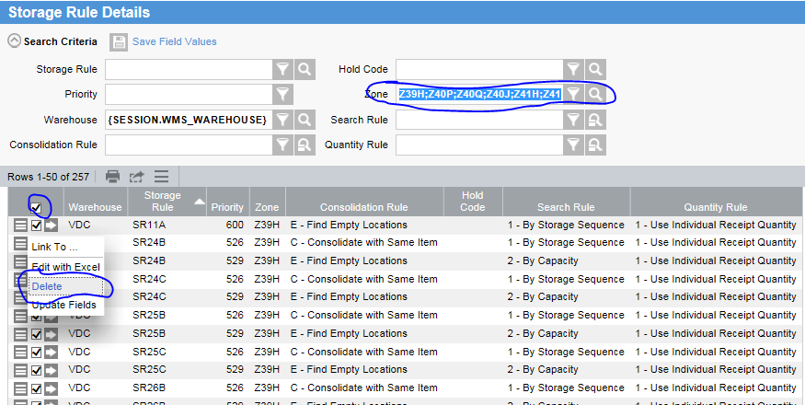

1. Update warehouse search rules to add new On Pack section
2. Once in the correct screen (Warehouse Searches) click on the arrow of the rule you want to modify.

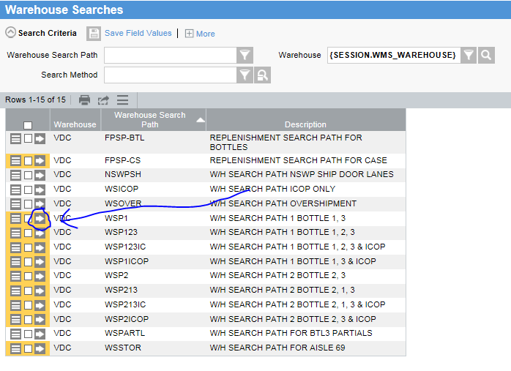

1. In the detail screen, add a new search records
   1. Populate fields
      1. Section: the new On Pack section you made earlier (ex: S-ONPACK)
      2. Priority and Search Method: check example, this decision is out of scope of this document.
      3. Click Add
   2. Do step a. for as many records as you have to add.
2. Once you have added all the records needed, click Submit on the bottom left of page to save your changes.

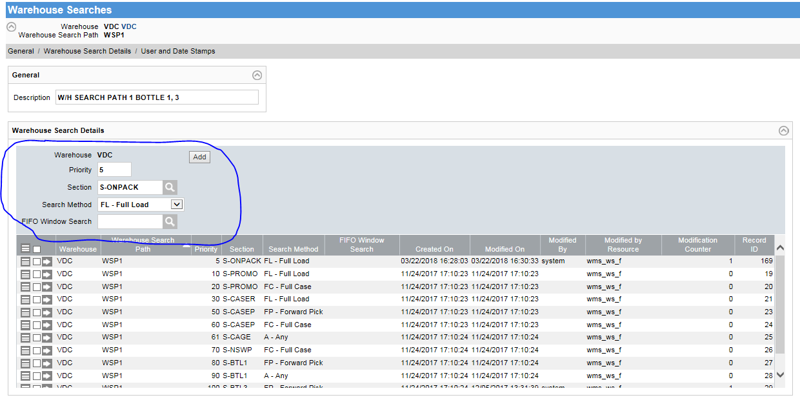

1. Do step 2-3 for every for every search needed. In this case; all the searches highlighted in Yellow from the first screen shot.

## Assignment to Location

The warehouse will use a mix of FIFO, BULK and FP (forward pick) location types. This assignment is done at the item level and will be completed by warehouse staff, it will not come from host.

## ICOP Hold

1 custom numeric field added to Item definition with values 0/1. Where “1” identifies the item as being on hold for ICOP, items on hold for ICOP print tags bearing a “H” on the upper right corner. Custom\_numeric\_4 is used for this identification.

## Bottle Pick Volumetrics by Sleeve

Bottle Pick will use sleeve based logic to fill containers. This logic is not a standard Tecsys functionality so some changes at the item level are required for the containerization to work correctly.

The containerization logic "by sleeve" can be realized given the following **conditions** are met:

* Tecsys doesn't not support separate fields to store an item sleeve dimension so UOM 1 dimension fields will be used
* Condition #1 requires the cubic volume of the UOM 1 to be smaller than the volume of UOM 2

Sizing of the bottle measurements are completely artificial and set up to match carton containers which accommodate 12, 6, and 2 bottles accordingly no matter what is the actual bottle size. For these purposes all product bottle sizes are corresponding with the container sizes and will be automatically updated by an iTopia rule which is triggered by the cubiscan interface. The sleeve sizes will be set up as follows:

* 12 Sleeve box bottle (measurements in cm)
  + Width = 1
  + Length = 1.2
  + Height = 12
* 6 Sleeve box bottle (measurements in cm)
  + Width = 1
  + Length = 1.1
  + Height = 13
* 2 Sleeve box bottle (measurements in cm)
  + Width = 1
  + Length = 1
  + Height = 14

Using UOM 1 dimension fields imposes several **limitations**:

* All products slotted into Bottle pick 1-2-3 area have to have one of three standard UOM 1 sizes – regular, large, or tall
  1. Only wines or spirits larger than 0.375 ml size can be slotted into bottle pick with some exceptions
* All products from bullet 1 cannot have UOM 1 dimensions overwritten by the cubic scan
* If the product is not slotted in bottle pick sections it will get sleve of 12 UOM1 sizes assigned by defalut
* If the product slotting changes (e.g. not bottle pick becomes bottle pick or vice versa, or bottle pick slot moves from BTL1-2 to BTL 3 or vice versa) two following changes have to be applied by an operator:
  1. Item UOM 1 dimensions to be changed change using Item Volumetrics Maintenance function (see SR # OUT.PIC.BR01.FR01.SR02 for SOP)
  2. All item instances dimensions for UOM 1 to be changed using Inventory Volumetrics Maintenance function (see SR # OUT.PIC.BR01.FR01.SR02 for SOP)

See Container Type and Container Selection code for more settings related to containerization by sleeve.

# Carrier

Carrier is defined in Tecsys as a group of carrier services. In the LDB implementation carrier service will correspond to a group of freight lanes such as all of VANKAM freight lanes.

## Carrier

Same as carrier service for LDB, created to represent groups of freight lane.

Fields:

* Carrier name
* Description 1 and 2
  + Used to describe the freight lane (optional)
* Standard Carrier Alpha Code
  + Not used

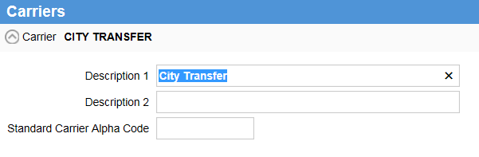

## Carrier Services

Carrier Service in Tecsys will represent the freight lanes matched to eBiz.

The carrier services must exist in Tecsys before an order using the carrier service (freight lane) is sent to Tecsys or the interface will accuse an error and the order will not be created.

* SOP for the business
  + If there is an order with a new carrier service, send with an existing freight lane and call to create the new carrier service in Tecsys and then move to the correct carrier service
  + Carrier and Carrier Services are NOT integrated tables, so changes in eBiz do not carry to WMS

To create carrier service:

* Enter name
* Associate carrier
* Select carrier service type like T – Truck service
* Small package – No
* Default Priority - 500
* Set destination location to blank
  + Order will be sent from eBiz with destination location set in order to SHIP0 (or other name to clue users into changing destination)
* Shipping
  + Set options below to Yes:
    - Master packing List
      * Contents of each pallet/container
    - BOL
      * Pallets/containers on shipment
    - Manifest Required
      * All BOL on Trailer
    - Verify Trailer
      * Forces trailer management
  + Set all other options to No

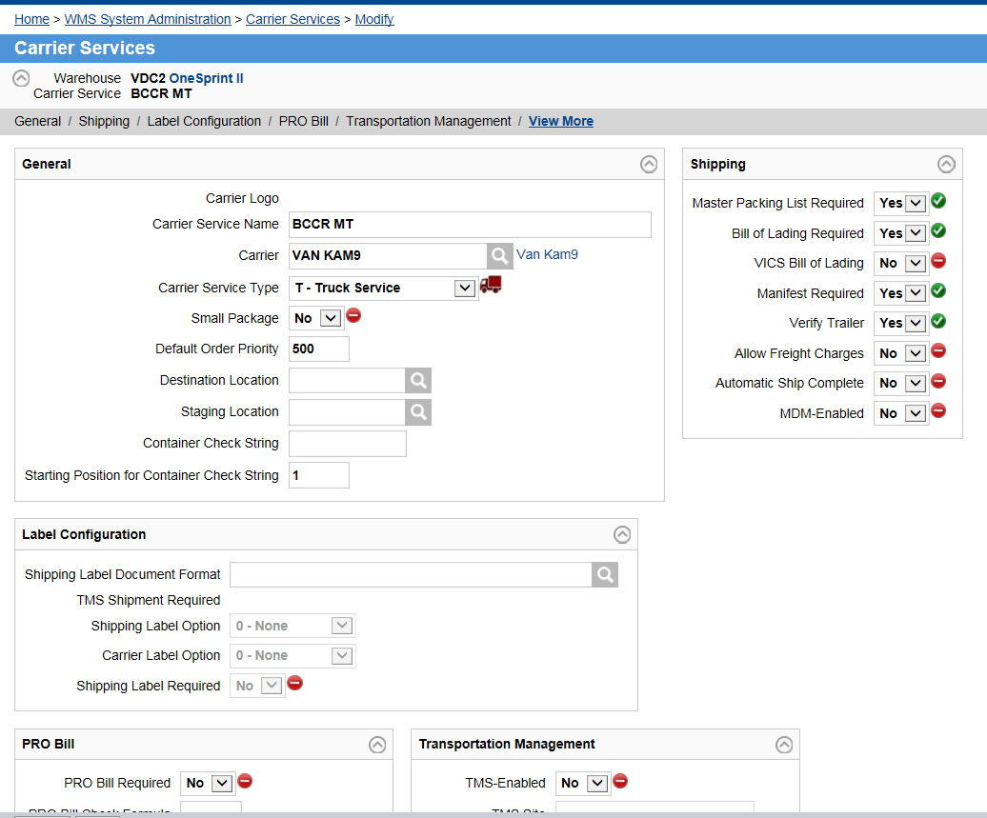

# Printing

Setting up printing involves multiple tables in Tecsys. Printing is part of process so the set-up takes into account besides simple send to printer correct document/label capabilities the processes being supported.

The printing configuration excel files are located in the SharePoint folder opened by this [link](http://headoffice.bcldb.com/projects/LDBDC/DC-WMS/Project%20Documents/Forms/AllItems.aspx?RootFolder=%2Fprojects%2FLDBDC%2FDC%2DWMS%2FProject%20Documents%2F30%20%2D%20Config%20and%20Dev%2FLDB%20SA%20Configuration%2FPackage%5FC%5FShipping%2FINT3%20Printing%20Set%2Dup%20Files&FolderCTID=0x012000E1B295AC7647614EACAF6ADA026AED15&View=%7b6AED93DD-9495-4191-A93F-4A1E6710A39E%7d). All the files referenced in the Printing section of this document are contained in the above SharePoint folder.

To set up Label printing:

* Set-up the Station
* Set-up Station Device
* Ensure all custom document mapping are completed for labels
* Ensure printer is set-up in Output Devices

To set up Document printing:

* Set-up the Station
* Ensure all custom document mapping is completed
* Ensure printer is set-up in Output Devices

## Stations

NOTE: Paper printers’ configuration for the GOLD environment is contained in StationGOLD.xls file on SharePoint and has three stations set up with paper printers – RECV, BASE, SHIP

Paper printers’ configuration for the INT3 test environment is contained in StationINT3.xls and has all stations configured to print to the PDF BULLZIP printer.

Stations control multiple attributes. The main configuration attributes being considered when stations are organized are label printer locations and processes being supported.

The station/printer distribution by process is:

|  |  |  |  |  |  |
| --- | --- | --- | --- | --- | --- |
| Process | Printer type | Count | Station Naming | Station Planning | Printer Name |
| Receiving | Label | 10 | Door  1 – 39  Printer  A, B, C, D, E ,F ,G ,H, J, K  Label  1 – Tag / NSWP Container 2 – Tag / SO Container | 704 stations used:  Base  ICOP  Stations that supports all combinations of 39 doors X 10 printers X 2 label types (tag and container) = 780 stations  Receivers would log into the combination of Door + Printer + label being used for receiving   * 27+D+1 = Station 27D1 * Receiving on door 27, using printer D, regular product and NSWP pallets | DDC\_MA12  DDC\_MB12  DDC\_MC12  DDC\_MD12  DDC\_ME12  DDC\_MF12  DDC\_MG12  DDC\_MH12  DDC\_MJ12  DDC\_MK12 |
| Receiving | Label | 1 | RECV | Receiving office | DDC\_RECV |
| NSWP | Label | 1 | NSWP | NSWP Area | DDC\_NSWP |
| Recoup | Label | 1 | RECP | Recoup | DDC\_RCP1 |
| Picking | Label | 6 | CPRE printers   * Base * CUST * SHIP * ICOP * Bottle1 * Bottle2 * Bottle3 | 6 Stations used:   * Shipping dispatch (planning waves and CPREs)   + Office printer for CPRE, container CSO, tag and shipping labels * Customer pick up * Shipping office (picked orders shipping) * Station ICOP * Station Bottle1 * Station Bottle2 * Station Bottle3 | DDC\_SHIP  DDC\_CPU1  DDC\_DISP  DDC\_ICOP  DDC\_ABT1  DDC\_ABT2  DDC\_ABT3 |
| Shipping | Label | 5 | Shipping label printers   * Base * CUST * SHIP * ICOP * Wrapper1 * Wrapper2 * Wrapper3 * Wrapper4 * Bottle Pick | 4 Stations used and 3 web calls:   * Shipping dispatch (same as picking) * Customer pick up (same as picking) * Shipping office (same as picking) * Station ICOP (same as picking) * No Station - Web call to external printer in Wrapper 1 * No Station - Web call to external printer in Wrapper 2   Station Wrapper3  Station Wrapper4  Web call to external printer in bottle pick 3rd floor | DDC\_SHIP  DDC\_CPU1  DDC\_DISP  DDC\_ICOP  DDC\_MPW1  DDC\_MPW2 |
| Shipping | Document | 1 | Document Printer   * Shipping Office | 1 Station used:  Base   * Printer for all docs; manifest, BOL, packing list, etc. | DDC\_SHP |
| Receiving | Document | 1 | Document Printer   * Receiving Office | SHIP | DDC\_REC |
| Dispatch | Document | 1 | Document Printer   * Dispatch Office | SHIP | DDC\_DIS |

Other configurable attributes in stations:

* For a user to change the printer, they go to the start screen and change the station at login
* Receiving station is defaulted
  + Default set to door where receiving is happening for receiving stations
  + All other stations are set to RECV1
* Warehouse search path is defaulted
  + Default set to WSP1
* Printer for different document types
* Default container types for different processes
  + For all receiving stations – set to "Default Container Type Receiving for Receiving" = "RPAL"
  + BASE + ICOP stations - update "Default Container Type Receiving for Pick” = "RPAL"
  + BTL1 + BTL2 + BTL3 stations - update "Default Container Type Receiving for Pick” = "BX2L"
  + ALL – update “Default Container Type for Replenishment” = REPL

Label details:

* Label type “Tag”
  + Used for single SKU pallets
* Label type “CNSWP”
  + Used for NSWP mixed pallets container labels
* Label type “CSO”
  + Used for Special Order containers
  + Receivers must be able to identify the order type so they can select the correct station
  + There are multiple types of special orders, each requires a separate station so that the label correctly prints the label
    - MVP Rollout
      * Special Order
    - Full Roll Out
      * Boudreaux RLS
      * Beaujolais RLS
      * VIWF
      * Partial Cases

## Station Devices

NOTE: Label printers’ configuration for the GOLD environment is contained in Station DeviceGOLD.xls file on SharePoint

Label printers’ configuration for the INT3 test environment is contained in Station DeviceINT3.xls and has all stations configured to print to the PDF BULLZIP printer. The exceptions will be stations 25A1, 25A2, 25B1, 25B2, 25C1, 25C2 which configured to print on so called Zebra1 physical test printer.

* Station device
  + Associate station to a label type and system document format name

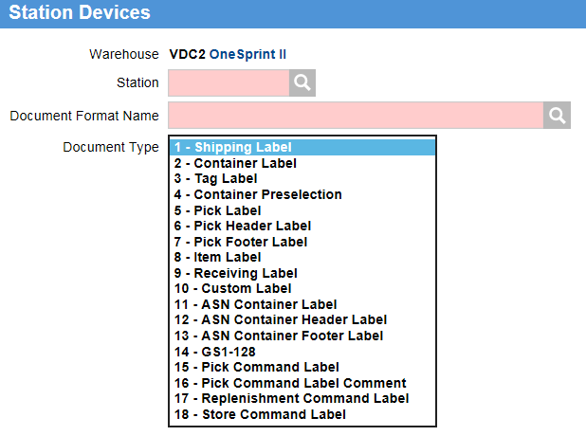

## Output Devices

NOTE: Output Devices for the GOLD environment are configured as per Output DevicesGOLD.xls file on SharePoint.

* Links logical printers to physical printers
* All printers need to be created in this table

Sample below from dev environment

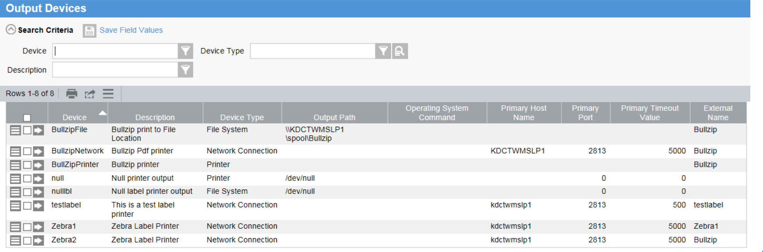

## Document Format Definition

Step:

* Create logical document format in the system
  + I.e.; Create Document Format wms\_default\_ldb
* Link logical name to Tecsys functionality (WMS)

Sample below from dev environment:



## Document Format to External Document Map

NOTE: External Document Maps for the GOLD environment are configured as per External Document MapsGOLD.xls file on SharePoint

External Document Maps for the INT3 environment are configured as per External Document MapsINT3.xls file on SharePoint

Step:

* Link logical name to Loftware document name

Sample below from dev environment

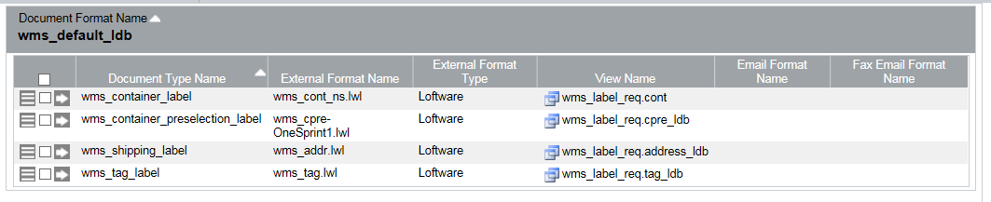

## Printing Trouble Shooting

* Check Station master for document set-up
  + Or check associated station device for label set-up
* Check sys\_mon in Tecsys to ensure print is being sent to queues
  + Check queues below
    - Stop and start queue if required to ensure queue is not stuck



* + Click to open queue list (press search) and select document details
    - Ensure there are no errors associated to the document

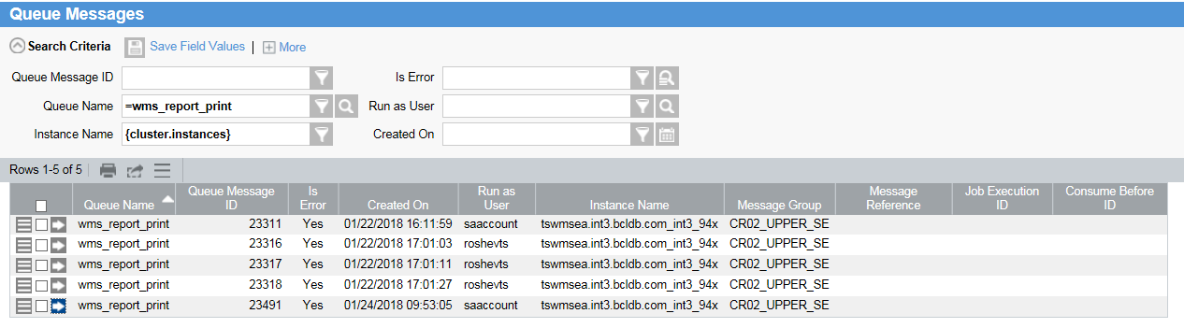

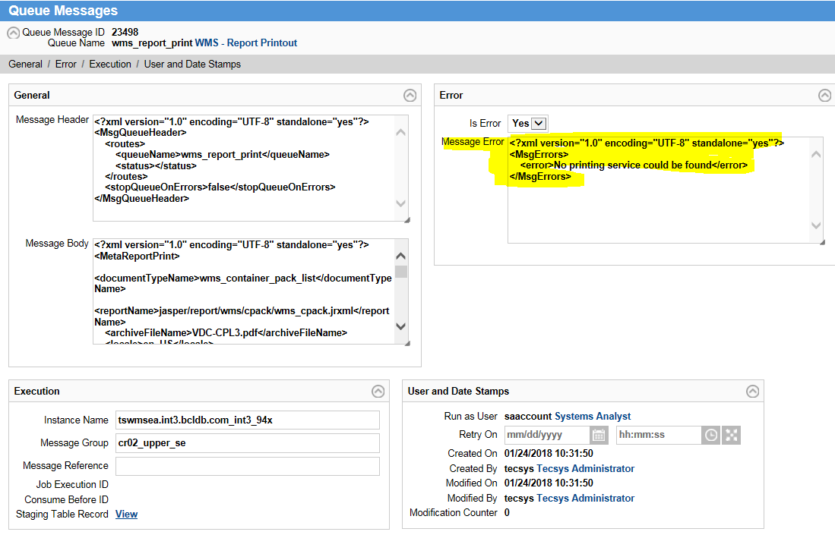

* If the error is “No printing service could be found”
  + Ping the printer from the application server
  + Verify set-up for printer in application server
* If the error is “BlaBla Jasper Folder Blabla”
  + Check if Jasper folder is created in application

# Labels

Container/Tag Data ID configuration

1. Data ID Generation prefixes:

* TAG – V for Vancouver Distribution Center and K for Kamloops Distribution Center
* CONT – C

1. For the purposes of printing the numbers of the same length the Last Generated Number setting was set to:

* CONT – 1000000 (prefix + 7 chars)
* TAG – 100000000 (prefix + 9 chars)

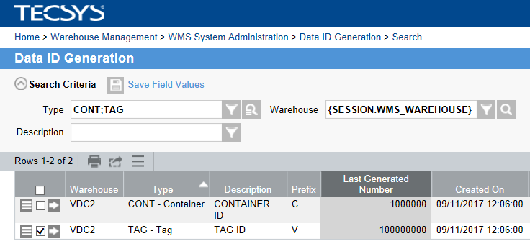

## Inventory/ Receiving Tag

There will be 3 container tags:

* Regular
  + Use for regular product pallet and NSWP single SKU pallets
  + Fields:
    - Scannable tag
    - Readable tag
    - Scannable item
    - Readable item
    - Purchase Order #
    - Item description
    - Date Received
    - Date Expiry
    - Quantity in pallet
    - UOM
    - Right Corner indicator
      * Blank if full load and not overshipped product
      * “NSWP” if single SKU NSWP pallet
      * “SO” if special order
        + Identified via the item name starting with “SO”``
      * “P” if pallet is a less then full load
        + Will require SQL to add to label as to has to verify what the full load for the product is and see if it is less
      * “H” if pallet is for overshipped product



* NSWP
  + Will use a Receipt label
    - Receipt# - scannable (big) and readable (small)
    - System date/time (date receipt)
    - Label Identification: NSWP
  + Used for Mix pallet of NSWP
    - Full pallets of NSWP use regular tag



* Special Order
  + Simplified Regular Label
    - Tag #
    - System date/time
    - Label identification: Special Order
    - Used for mix pallet of Special Order
  + Special Products must be identified as a special product in system
    - Item name starts with “SO”



## CPRE configuration details

Which station and as the result printer will be used for printing the CPRE labels is based on the Area configuration.

Container Selection Code Station is dictating the station selection. For example, if the pick command is generated for a location in the AB1R area then the station BTL1 will be used for printing. The actual printer to be used for station BTL1 can be looked up in Station Devices view.

The Areas Container Selection Code Station is configured in the following way:

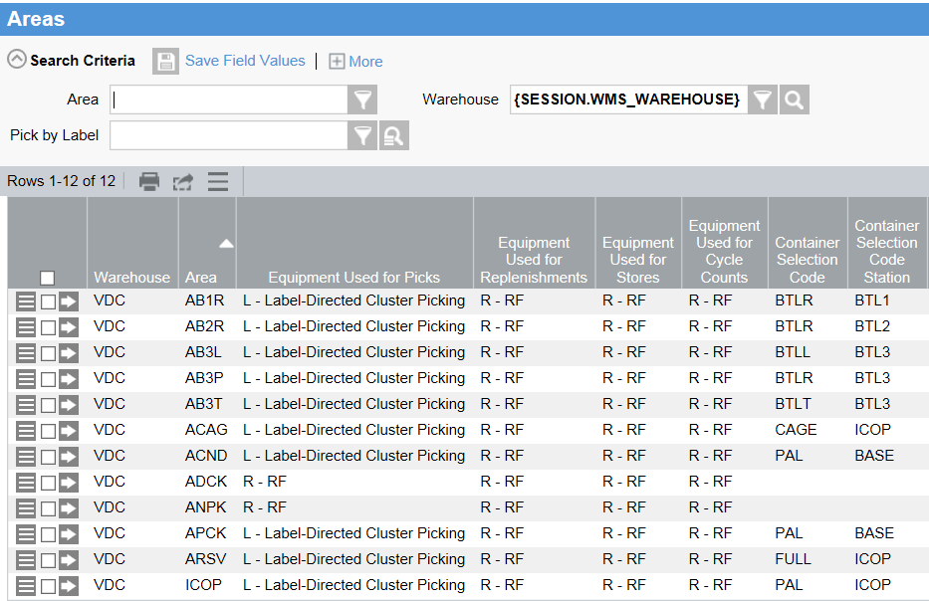

## CPRE

Used for all picks in warehouse including:

* Case pick
* Bottle pick
* Full pallet pick

### Case Pick

Fields to print in CPRE:

* Customer Number
* Customer Ship to Name
* Delivery address
  + Address
  + City
  + Province
  + Postal Code
  + Country
* Container ID
* Destination
  + Cannot display wrapper or QA as these are route points and not destinations
  + The destination location displayed will be the ship lane
* Container type
* Warehouse (location)
* Order number/ delivery ID
* Ship date
* Ship time
* Created date
* Created Time
* Upper Right Corner Value
  + C - value container
  + F - value full load
* Big Number
  + Last 4 digits of the order
* Container: X of Y --- Deferred
* Created time

The last case pick CPRE label for an order that has bottle pick will display:

* “B” to indicate there are cases in bottle pick

Pending from Tecsys:

* What happens if an order is just bottle pick?
  + Zero case picks, will a CPRE just for the bottle case picks still print?

### Bottle Pick

Fields to print in CPRE:

* Same as Case Pick
  + Except for no “B” on any label
* One label printed per case

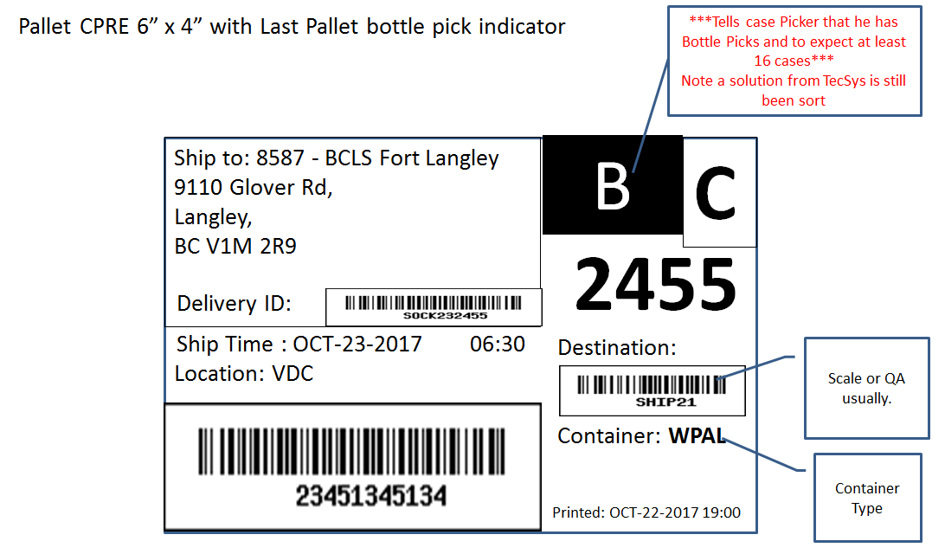

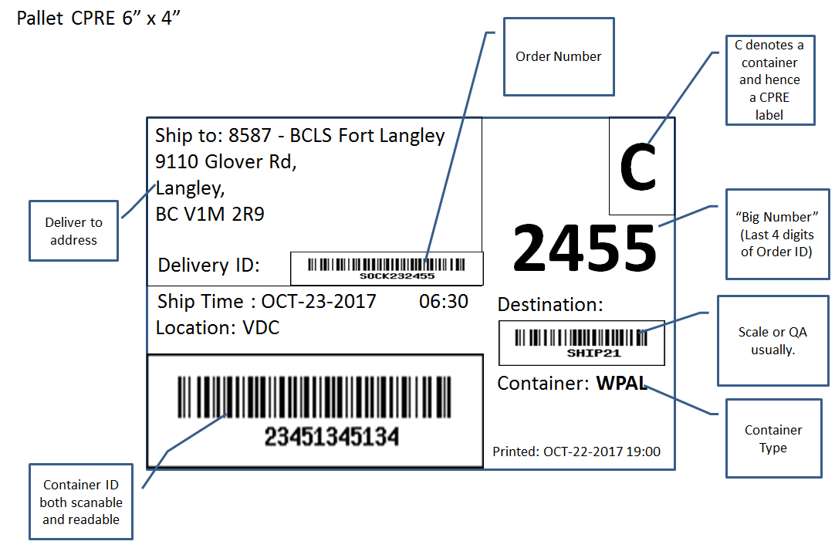

## Shipping label configuration details

The Shipping label document design can be set up in multiple places in Tecsys. These places have the hierarchy such as:

* Outbound Orders (om\_f – highest, wins below ones) – Customer-Specific Shipping Label Document Format
* Carrier Services (ca\_f – higher) – Shipping Label Document Format field
* Warehouse options (so\_f - lowest) – Document Format Name field

Currently, the default setup is done in the Warehouse Options:

Document Format Name = wms\_lbl\_ldb

## Shipping Label

Used for all shipping in warehouse. Fields to print in shipping label:

* Ship date
* Ship time
* Customer Number
* Customer ship to
* Delivery address
  + Address
  + City
  + Province
  + Postal Code
  + Country
* Order number/ delivery ID
* Container ID
* Warehouse address
  + Whs Name
  + Ship From Name
  + Address
  + City
  + Province
  + Postal Code
  + Country
* Destination
* Created Date
* Upper Right Corner Value
  + S - value
* Big Number
  + Last 4 digits of the order
* Container: X of Y
  + Deferred
* Created Time
* Actual shipping weight
  + Waiting for Tecsys

For bottle pick shipping label only:

* Content
* Count of items in case

Tecsys will print shipping labels where users request it such as in the manual wrappers. But in the automated wrappers and on the 3rd floor of the bottle pick the labels are printed by the integrated WSC systems provided with the conveyors. Tecsys will do a web call to the external device and supply all the data required for the external printer to build the label. Label format is NOT included in the web call. These are configured at the external printer (TBD on actual software used).

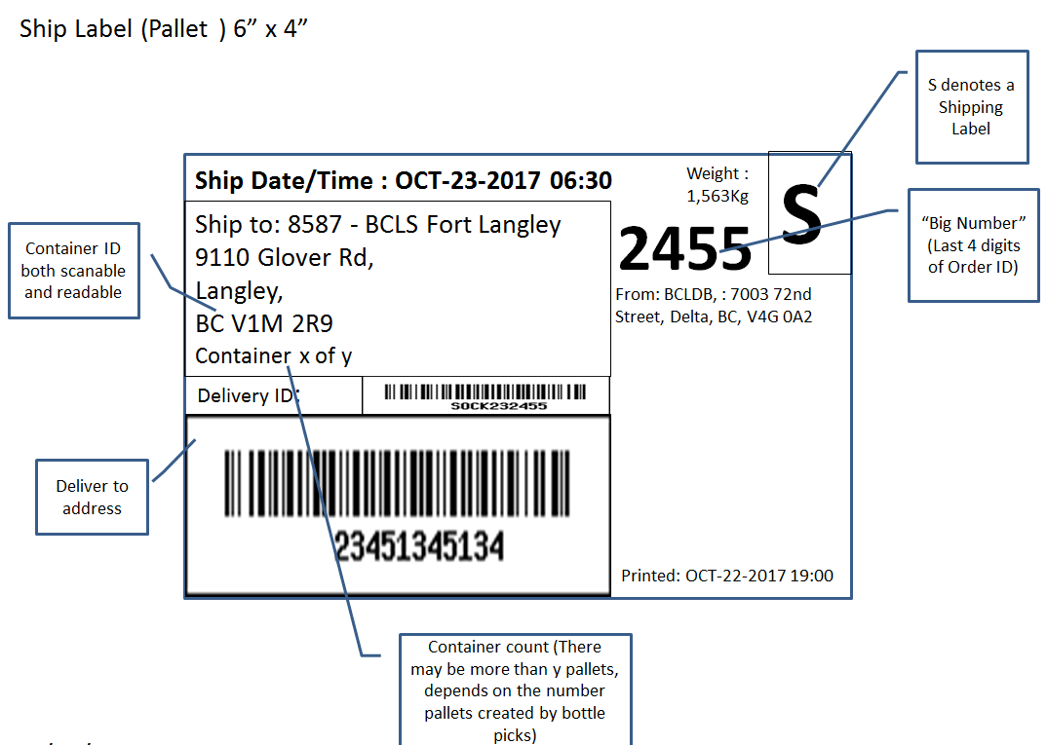

# Documents

In order to print paper document the Stations have to be pointed to the paper printers.

As per requirements 3 stations should be able to print paperwork: BASE, RECV, and SHIP. The printers are configured as follows:

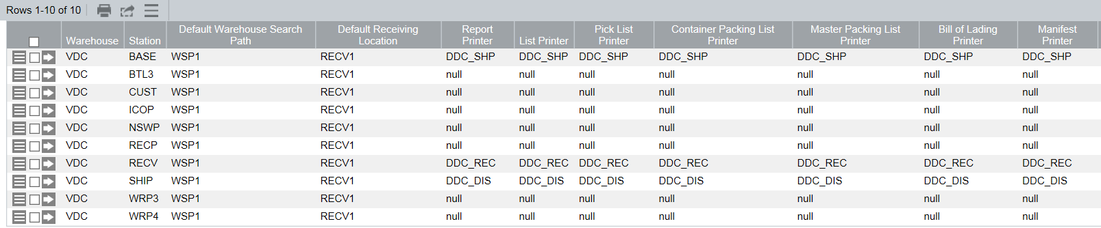

These custom LDB documents should be printing from the system:

* BOL
* Manifest
* Container packing List
* Master Packing List

# LDB Custom Views and Columns

There is a list of custom views and data column created in the system where Tecsys standard functionality did not fulfill the business needs.

Link to document listing all custom views and columns.

<http://headoffice.bcldb.com/projects/LDBDC/DC-WMS/Project%20Documents/30%20-%20Config%20and%20Dev/LDB%20SA%20Configuration/Configuration%20Documents/WMS%20Metadata%20Configuration%20Exceptions.xlsx>

# Warehouse Options

Currently using mostly default settings supplier by Tecsys.

## Definitions

|  |  |  |  |  |  |  |  |
| --- | --- | --- | --- | --- | --- | --- | --- |
| **Section** | **Field** | **Value** | **Reason/FR** | **Need FR** | **Vis-SysAdmin** | **Vis-Mgr** | **Vis-** |
| Ship From | Transaction Reset Status | Disabled | This option should not even be in the view. |  | Y | N | N |
| Warehouse Name | VDC |  |  |  |  |  |
| Ship-From Name |  | ? | ? |  |  |  |
| Address 1 | 7003 72nd Street |  |  |  |  |  |
| Address 2 |  |  |  |  |  |  |
| Address 3 |  |  |  |  |  |  |
| City | Delta |  |  |  |  |  |
| State or Province | BC |  |  |  |  |  |
| Country | Canada |  |  |  |  |  |
| Zip or Postal Code | V4G 0A2 |  |  |  |  |  |
| Phone Number |  | ? |  |  |  |  |
|  |  |  |  |  |  |  |  |
| Receiving | Clear Quantity | No | Value of 'No' allows end user to See Receiving Qty |  |  |  |  |
| Over Receipt Tolerance | 0 | Do not allow physical over receipt |  |  |  |  |
| Potential Cross Dock | Yes | To enable cross dock in system |  |  |  |  |
| Manufacturer | BLANK | Not required ( we don't generate SCC codes ) |  |  |  |  |
| Warehouse GLN | ? |  | Y |  |  |  |
| Confirm Container Count at ASN Receiving | 0 – None |  |  |  |  |  |
|  |  |  |  |  |  |  |  |
| Picking and Shipping | Allow Multiple Lots in a FP Location | Yes | LDB will not restrict using lots for inv mgmt |  |  |  |  |
| Wave Planning by Shipment - Include All Orders | No | LDB will not restrict a shipment to a single order |  |  |  |  |
| Allow Order Planner to Break Forward Pick | No | Tecsys Recommendation |  |  |  |  |
| Store in Containers | Yes | All containers are shipable |  |  |  |  |
| Container Preselection | Yes | Allows LDB to assign containter based on area/section |  |  |  |  |
| Container Preselection Label Print | Yes | Needs to be Yes to print CPRE. |  |  |  |  |
| Split Pick List and Labels by Area | Yes |  |  |  |  |  |
| Split Pick List and Labels by Shipment | Yes | Enables gen of pick list and labels for every order/area combo |  |  |  |  |
| Split Pick List and Labels by Order | Yes | Will further split by order/shipment/area | ? |  |  |  |
| Split Pick List and Labels by Container | Yes | Needed for bottle pick vs pallet |  |  |  |  |
| Pick Front Inventory | Yes | Implies FIFO will be used in search path |  |  |  |  |
| Pick Substitute Items | Yes | Recommended by Tecsys unless DMS is installed |  |  |  |  |
| FIFO-Pick Ordered Item | No | Recommended by Tecsys unless OMS is installed |  |  |  |  |
| FIFO-Pick Front Inventory | Yes | ?? | ? |  |  |  |
| Group Picking Allowed | No | ?? | ? |  |  |  |
| Maximum Lines per Group | 9999 | ?? | ? |  |  |  |
| Maximum Number of Labels per Item | 100 | number of pick labels printed for an item, tag, and UOM combination | ? |  |  |  |
| Maximum Labels per Item Before Warning | 50 | ? | ? |  |  |  |
| Maximum Lines per Wave Template | 500 |  |  |  |  |  |
| Packer Warning of Backorder Lines | 0 - Never | LDB does not backorder |  |  |  |  |
|  |  |  |  |  |  |  |  |
| Defaults for Bill of Materials | Work Order Pick Destination |  | ? |  |  |  |  |
| BOM Receiving Location |  | ? |  |  |  |  |
| Release BOM for Putaway | Yes | ? |  |  |  |  |
| Default Label Copies Requested for BOM Item | 0 | ? |  |  |  |  |
| BOM Component Return Location |  | ? |  |  |  |  |
| Release BOM Component Return Labels | Yes | ? |  |  |  |  |
| Number of BOM Component Return Labels | 0 | ? |  |  |  |  |
| BOM and Component Print Station |  | ? |  |  |  |  |
|  |  |  |  |  |  |  |  |
| Defaults for Customer Returns | Customer Return Receiving Location |  |  |  |  |  |  |
| Damaged Return Hold Code |  | ? | ? |  |  |  |
| Release Customer Returned Inventory for Putaway | No | Must go to QA first | ? |  |  |  |
| Number of Customer Return Labels | 1 |  |  |  |  |  |
| Non-Returnable to Stock Hold Code |  |  |  |  |  |  |
| Non-Returnable to Stock Location |  |  |  |  |  |  |
|  |  |  |  |  |  |  |  |
| Defaults for Vendor Returns | Hold Code for Shipment to Vendor |  | ? | ? |  |  |  |
| Inventory Disposal Hold Code |  | ? | ? |  |  |  |
| Destination Location for Inventory Disposal |  | ? | ? |  |  |  |
|  |  |  |  |  |  |  |  |
| Host | Host System | 4 – Other |  |  |  |  |  |
| Upload Item Package Code Source | 2 – WMS |  |  |  |  |  |
| Allow UPC Multiplicity | No |  |  |  |  |  |
| Host Station | BASE |  |  |  |  |  |
| Non-Stock Template Item |  |  |  |  |  |  |
| Non-Stock Template Package |  |  |  |  |  |  |
|  |  |  |  |  |  |  |  |
| Defaults for System | Default Station | BASE |  |  |  |  |  |
| Document Format Name | wms\_lbl\_ldb |  |  |  |  |  |
| Locale | en\_US | ? en\_CA? |  |  |  |  |
| Dimensions Recorded Using Metric Measurements | Yes |  |  |  |  |  |
| Days of Operation Calendar |  | ? |  |  |  |  |
| Billing Start Date | Current Date |  |  |  |  |  |
| DSCSA Statement |  | ? |  |  |  |  |
|  |  |  |  |  |  |  |  |
| Defaults for Dedicated Orders | Dedicated Order Inventory Attribute | 1 – Inventory Attribute 1 | Dedicated Orders not used for MVP |  |  |  |  |
| Dedicated Order Receiving Method | 3 – As Specified by User | Dedicated Orders not used for MVP |  |  |  |  |
| Dedicated Order Receiving Container Type |  | Dedicated Orders not used for MVP |  |  |  |  |
|  |  |  |  |  |  |  |  |
| Defaults for TMS | TMS Shipment Level for Parcel Service | 2 – Shippable Unit | TMS not used for MVP |  |  |  |  |
| Weight Limit for Parcel Carrier | 40,000.00000 | TMS not used for MVP |  |  |  |  |
| Maximum Weight per Parcel | 1,000.00000 | TMS not used for MVP |  |  |  |  |
|  |  |  |  |  |  |  |  |
| Defaults for Cycle Count | Cycle Count Method | ITEM | Required for cycle counts to work properly |  |  |  |  |
| Automatic Cycle Count | YES |  |  |  |  |  |
| Maximum Number of Automatic Cycle Counts | 1 |  |  |  |  |  |
|  |  |  |  |  |  |  |  |
| Defaults for Putaway | Storage Scheduler Timeout | 00:01 | ? |  |  |  |  |
| Volumetric Tolerance | 5.00 | ? |  |  |  |  |
| Default Load Height | 64.00000 | ? |  |  |  |  |
| Default Pallet Width | 40.00000 | ? |  |  |  |  |
| Default Pallet Depth | 48.00000 | ? |  |  |  |  |
| Default Pallet Thickness | 6.00000 | ? |  |  |  |  |
| Tag Pickup Confirmation Required | No | ? |  |  |  |  |
|  |  |  |  |  |  |  |  |
| WMS-to-Host Interface | Summary for Receipts | 1 – Summary by Inbound Order and Receipt |  |  |  |  |  |
|  | Include All Inbound Order Lines | Yes |  |  |  |  |  |
|  | Summary for Shipments | Yes |  |  |  |  |  |
|  | Include All Outbound Order Lines | Yes |  |  |  |  |  |
|  | Host Packing List Print | No | ? |  |  |  |  |

# Data ID Generation

Currently using mostly default setting supplier by Tecsys.

The exceptions are set up as follows:

Navigate to Home > Search > Data ID Generation

Select Type:

* TAG - Tag
  + Set to start with V for Vancouver tags and K for Kamloops tags.
  + Start set to 10000000
* CONT - Container
  + Start set to 1000000

# Transaction History Purge

As per SR# 4.1.BR.6.SR64.4 to meet the government regulations for the transaction history retention Cognos software will be used. This software should be able to extract data on the daily basis. This makes Transactions retention configuration in Tecsys only dependant on operational requirements. As per above considerations the transactions retention periods in Tecsys are set up in the following way:

|  |  |  |  |
| --- | --- | --- | --- |
| **Warehouse** | **Purge Task Code** | **Task Description** | **Maximum Number of History Days** |
| VDC | ADJ | Inventory Adjustment | 730 |
| VDC | ASN | ASN SHIPPED CONTAINERS | 730 |
| VDC | AUTO | System-Generated Wave | 730 |
| VDC | CADJ | CYCLE COUNT ADJUSTMENT | 730 |
| VDC | CAN | ORDER CANCEL | 730 |
| VDC | CBLD | CONTAINER BUILD | 730 |
| VDC | CCAN | CYCLE COUNT ORDER CANCEL | 730 |
| VDC | CEXA | Cycle Count Exception Approved | 730 |
| VDC | CEXC | Cycle Count Exception Recounted | 730 |
| VDC | CEXP | CYCLE COUNT EXCEPTION | 730 |
| VDC | CEXR | Cycle Count Exception Rejected | 730 |
| VDC | CEXW | Cycle Count Exception Waiting Approval | 730 |
| VDC | CMRG | CONTAINER MERGE | 730 |
| VDC | CNSM | Consume Component | 730 |
| VDC | CTMN | Close TMS Manifest | 730 |
| VDC | CTSH | Create TMS Shipment | 730 |
| VDC | CYCC | CYCLE COUNT PERFORMED | 730 |
| VDC | DADJ | Host Inventory Adjustment Deleted | 730 |
| VDC | DCOM | Decommission | 730 |
| VDC | DOPK | Dedicated Order Pick | 730 |
| VDC | DTSH | Delete TMS Shipment | 730 |
| VDC | HADJ | Host Inventory Adjustment Applied | 730 |
| VDC | HIST | PURG OTHER TRANSACTION HISTORY TABLES | 730 |
| VDC | HOLD | ORDER PLACED ON HOLD | 730 |
| VDC | LGIN | LOG IN | 5 |
| VDC | LGOT | LOG OUT | 5 |
| VDC | LOAD | CONTAINER/TAG LOADED ONTO TRAILER | 730 |
| VDC | LSUB | LOCATION/TAG SUBSTITUTION IN STORE, PICK | 730 |
| VDC | MOVE | INVENTORY MOVE RELOCATION | 730 |
| VDC | NEST | CONTAINER NEST | 730 |
| VDC | OCHG | Order Freight Charges | 730 |
| VDC | PACK | ENTIRE ORDER PICK COMPLETED | 730 |
| VDC | PAPR | Picking Verification Approved | 730 |
| VDC | PASN | Purge ASN Tables | 730 |
| VDC | PCAR | Purge Carousel Completion | 730 |
| VDC | PICK | PICK COMMANDS FOR A SHIPMENT ARE COMPLET | 730 |
| VDC | PINS | Purge Inventory Snapshot | 730 |
| VDC | PPWK | Purge Paperwork Lists | 730 |
| VDC | PREJ | Picking Verification Rejected | 730 |
| VDC | PRI | ORDER PRIORITY CHANGED | 730 |
| VDC | PSHP | CONTAINER/TAGE HAS BEEN ADDRESS LABELED | 730 |
| VDC | PSTG | Purge Staging Tables | 365 |
| VDC | PUPL | Purge History Table | 365 |
| VDC | QARH | Quarantine Hold | 730 |
| VDC | QARR | Quarantine Released | 730 |
| VDC | RADJ | Replenishment Adjustment | 730 |
| VDC | RCLS | Receipt Closed | 730 |
| VDC | RCPT | RECEIPT OF PRODUCT | 730 |
| VDC | RDY | ORDER READY FOR PICKING | 730 |
| VDC | REPL | REPLENISHMENT | 730 |
| VDC | RPCK | ROUTED PICK | 730 |
| VDC | RRCL | Return Receipt Closed | 730 |
| VDC | RRCV | Customer Return Received | 730 |
| VDC | RREP | ROUTED REPLENISHMENT | 730 |
| VDC | RSTO | ROUTED PUTAWAY (STORE) | 730 |
| VDC | RTSH | Release TMS Shipment | 730 |
| VDC | SHIP | SHIP COMPLETE | 730 |
| VDC | SHPL | SHIPMENT LOADED | 730 |
| VDC | SLOC | LOCATION OVERRIDE ON STORE (PUTAWAY) | 730 |
| VDC | STAT | INVENTORY STATUS CHANGE | 730 |
| VDC | STOR | PUTAWAY/STORE MATERIAL | 730 |
| VDC | STSH | Submit TMS Shipment | 730 |
| VDC | SUSP | ORDER SUSPENDED | 730 |
| VDC | SYDN | System Down | 730 |
| VDC | SYUP | SYSTEM STARTUP | 730 |
| VDC | TAGE | TASK AGING | 730 |
| VDC | TRCL | Trailer Closed | 730 |
| VDC | TRID | TRAILER ID ASSOCIATION WITH A DOOR LOCAT | 730 |
| VDC | UBDT | Use-By Date and Time | 730 |
| VDC | UNPK | Container Unpacked | 730 |
| VDC | VADR | Void Address Label | 730 |
| VDC | VBOL | VOID BILL OF LADING | 730 |
| VDC | VCPK | Void Container Pack List | 730 |
| VDC | VMAN | VOID MANIFEST | 730 |
| VDC | VPAK | VOID PACKING LIST | 730 |
| VDC | VTSH | Void TMS Shipment | 730 |

# Void Paperwork Criteria

See Transaction History Purge section for the configuration details.

# Queue Timers

Queue timers and their schedule can be seen in the corresponding view. They are as per default system configuration.

# Appendix 1 – Storage Rule Implemented Plan